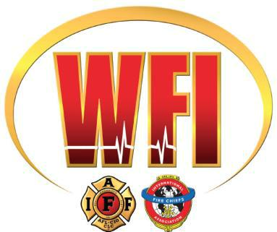

Wellness and Fitness Program
Grant Guidance

The FY2019 Assistance to Firefighters Grant (AFG) for Training and Equipment is a great opportunity to apply for grant funding to implement the International Association of Fire Fighters (IAFF)/International Association of Fire Chiefs (IAFC) Wellness-Fitness Initiative (WFI) and Peer Fitness Trainer (PFT) Programs in your department.

FEMA continues to emphasize the importance of fire fighter health and safety. Wellness and Fitness programs are intended to improve the quality of life of first responders so that their mental, physical, and emotional capabilities are resilient to withstand life’s demands with emergency services response.

Proposed training projects that benefit the highest percentage of applicable personnel within a fire department, or that will be open to other departments in the region, will receive the highest consideration and thus have a competitive advantage. It is possible to submit a regional application (multiple departments participating) for these programs, however, as part of the application you must submit MOU’s on department letterhead from each participating agency.

To learn more about the AFG application process click here. You will find several resources to assist you in preparing your application, including:
- AFG Application Information Get Ready Guide
- AFG Narrative Get Ready Guide
- AFG Program Guidance

*If FEMA has not yet posted the Notice of Funding Opportunity Announcement (NOFO), application link, or start dates of the application, you can sign up to receive email alerts when FEMA releases that information.

In order to be eligible for grant funding, fire departments must offer, or plan to offer, all five of the following (these are referred to as Priority 1 Activities): IAFF Peer Fitness is a Wellness and Fitness Priority 2 Activity.

Priority 1 Activities:
- Periodic health screenings
- Entry physical examinations
- Immunizations
- Behavioral health programs
- Cancer Screenings

Applicants must have all five of these Priority 1 activities already in place (or request the missing Priority 1 activities to have all five in place), or they will be unable to request any Priority 2 activities in their application.

Priority 2 Activities

To include but not limited to:
- Formal Fitness and Injury Prevention Program
- Critical Incident Stress Management Programs
- Employee Assistance Programs
- Injury/Illness rehabilitation programs
- Candidate physical ability evaluation
- Formal fitness and injury prevention program/equipment
- Injury/illness rehab
- IAFF/IAFC peer fitness trainer program(s)

Eligible Expenditures:

- Procurement of entry-level physicals that meet NFPA 1582
- Annual medical/fitness health evaluations consistent with NFPA 1582
- Immunizations, as recommended by the department or law (e.g., NFPA)
- Behavioral health programs
- Implementation of the International Association of Fire Fighters (IAFF)/International Association of Fire Chiefs (IAFC) Peer Fitness Trainer programs
- Contractual costs (non-hiring) for personnel, physical fitness equipment (including shipping charges and sales tax, as applicable), and supplies directly related to physical fitness activities

Ineligible Expenditures
- Transportation expenses
- Fitness club memberships for participants or their families
- Non-cash incentives (t-shirts or hats of nominal value, and vouchers to local businesses or time-off)
- Purchase of real estate
- Cash incentives
- Purchase of medical equipment that is not used as part of the Wellness & Fitness program
- Contractual services with anyone other than medical professionals (e.g., health care consultants, trainers, and nutritionists)
- Medical exams that do not meet NFPA 1582

Remodeling/Renovations of Existing Facilities
Remodeling/renovations to an existing facility to house a fitness activity, such as exercise or fitness rooms, showers, etc. must be minor interior alterations that do not change the buildings footprint, cost less than $10,000, and are justified in the Request Details narrative for the Wellness and Fitness activity. In order to be eligible, renovations must be essential to the successful completion of the grant scope of work. Any request for modifications to facilities may require an Environmental and Historic Preservation (EHP) Review. Additional information may also be required for EHP Review.

IAFF Peer Fitness Training Program
The Criteria Development Panel recommended that AFG continue to emphasize the importance of training in the AFG program with respect to fire departments. FEMA continues to emphasize the importance of training in the AFG grants program and has determined the highest benefit is derived from instructor-led training that is hands-on and leads to a national or state certification. Therefore, applications focused on national or state certification training, including train-the-trainer initiatives, receive a higher competitive rating. Instructor-led training that requires students to demonstrate academic competence and/or practical proficiency for certification will receive a high competitive rating. Instructor-led training that does not lead to a certification as well as any self-taught courses will not be high priorities.

Proposed training projects that benefit the highest percentage of applicable personnel within a fire department, or that will be open to other departments in the region, such as IAFF/IAFC Fire Service Wellness-Fitness Initiative and Peer Fitness Trainer Programs, will receive the highest consideration and thus have a competitive advantage. Large departments with a high number of active fire fighters will receive additional consideration when applying under the Fire Fighter Training Activity.

Eligible uses of training funds include but are not limited to:

- Tuition, exam/course fees, and certifications/certification expenses
- Purchase of training curricula, training equipment (trailers, mobile simulators), training props and training services (instructors)
- Overtime expenses paid to career fire fighters to attend training or to cover colleagues who are in training

Ineligible Activities:

- Construction of facilities (buildings, towers, etc.)
- Site preparation to accommodate any training activity, facility, or prop
- Firefighting equipment, or PPE, for use in training exercises, such as SCBA
- Purchase or lease of real estate
- Remodeling not directly related to grant activities

Training is categorized as a High (H), Medium (M) or Low (L) funding priority; within these categories, listed activities have an equal funding priority. Fire fighter safety and survival is categorized as a HIGH priority.

Other Scoring Considerations:
- Multiple departments trained
- Number of fire fighters trained
- Instructor-led vs. media-led
- Population served Call volume

Once you access the online application for the AFG program, you will begin by completing sections of the applications with demographic information specific to your department. It is recommended that you review these sections as soon as possible so you can begin to gather the required information.

We recommend typing your Narratives in a Word Document outside of the application, then copying and pasting it into the written narrative sections. Otherwise, the application will time out and you will lose what you have written.
- After pasting your narratives in each section, we recommend fixing any formatting issues.
- When typing your narratives, it is best to use small paragraphs.
The AFG Application:
The first sections of the application are about your organization.

Applicant characteristics: includes a narrative section where you must describe your critical infrastructure.

Discuss:
  - Schools and Universities
  - Health Care Facilities
  - Chemical or Manufacturing Facilities
  - Transportation Infrastructure – Roads, Bridges, Ports, Rail.
  - Large Commercial or Industrial Sites
  - Power plants, water / sewer treatment, dams, etc.
  - If we ever have anything at that place – Look Out!

Operating budget: includes a narrative section where you must describe your organization's need for Federal financial assistance. There is a 4,000-character limit to this narrative.

Your Financial Need narrative should address why your organization has been unable to fund your request locally, including such details as:
- Describe why you can’t complete this project without the assistance of federal funds.
- Compare your income to expenses in order to illustrate current funding deficiencies.
- Show other attempts you have made to fund department needs.
- Describe your community/agency budgets including:
  - Where money comes from
  - Where money goes
- What are your funding challenges?
- Provide attempts to acquire funding from other sources
- Describe operating budget limitations
- What does the future look like? Are revenues likely to increase or decrease and why?
- List primary sources of revenue, average annual operating budget over the last several years, how much is dedicated to personnel costs etc.?
- What are the consequences for not receiving the award?
- Will you be able to provide this critical training without this award?
- Will this place fire fighter lives at risk?
- Describe financial stressors.
  - Other capital projects
  - Unemployment rate
  - Loss of tax base
  - Non-tax paying entities
  - Any deficit spending from previous years that must be paid this year
  - Anything putting a strain on your budget
- What has your department done to control costs? Has the union offered concessions?
  - If so, state, “IAFF local ## has provided concessions…”
  - Have fire prevention or other staff been moved to front line positions to reduce overtime?
- Define and explain local terms.
  - For example, explain any tax levy limiting legislation that you may have in place in terms that someone not familiar with your area will understand.
- Has your department had large expenditures which limited your ability to pay for the requested equipment?
  - Perhaps you recently added personnel or are playing catch-up after years of neglecting the capital budget because all funding was directed to keeping fire stations open.
- If you have shown budget increases for prior years, or have a large reserve, explain where funds are directed and why they can’t be used.
  - For example, station or apparatus replacement, pension obligation increases, etc.
- Provide an itemized budget breakdown

Applicant and community trends: includes statistics on injuries and apparatus information.

Community description: includes a narrative section where you must describe your organization and/or community that you serve. There is a 4,000-character limit.

Discuss:
- Number of residents served
- Number of square miles protected
- Number and types of responses
- Describe the area you protect
- Critical infrastructure protected by your organization
- Firefighter I and II training and certification
- What are your community’s greatest needs, risks and challenges and how does your request address these?

Call volume: Department Specific Call Volume Data

Grant request details: This is where you begin to complete the information specific to the IAFF Peer Fitness Program.

- Click the “Add Activity” button

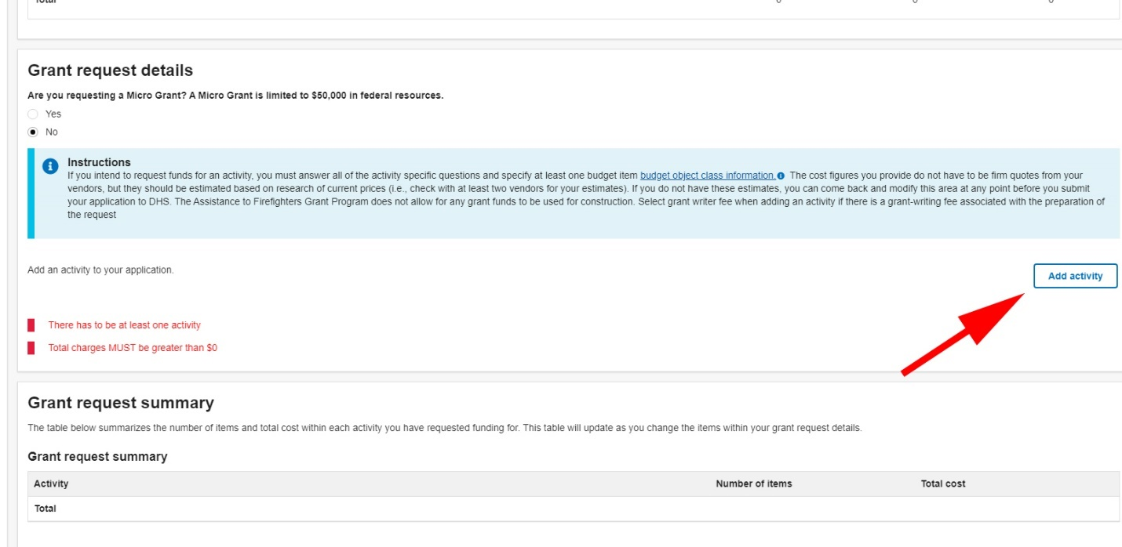

- Select “Wellness and Fitness” from the list

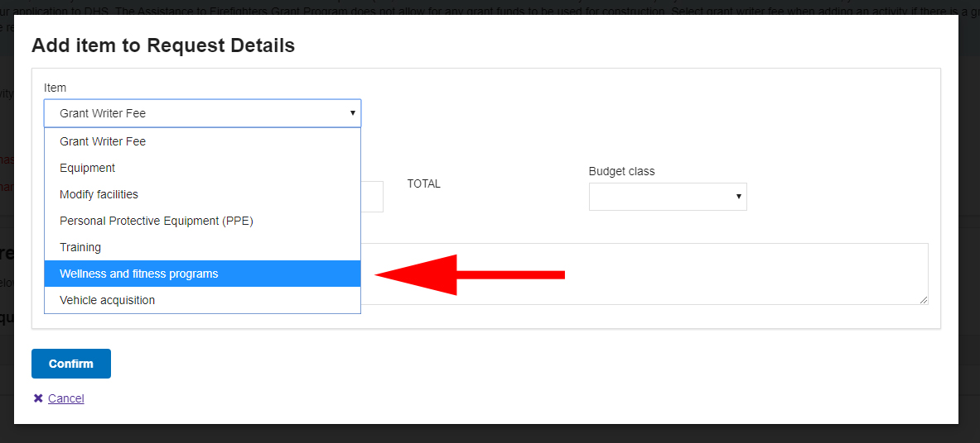

- This adds the main Narrative Fields to the application.
  - This will be addressed later in this guide

Fill out the section that appears asking about the Wellness and Fitness Priority 1 areas

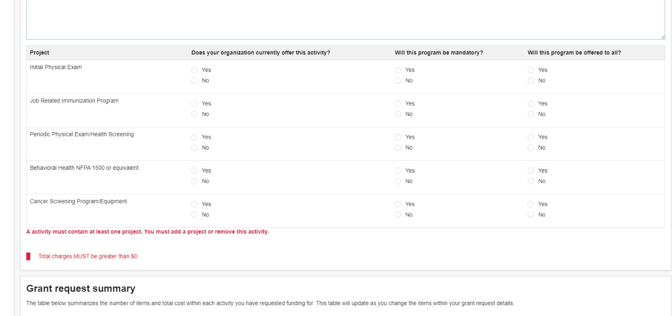

Answer all the questions regarding your department’s current status of Wellness and Fitness programs. If you say no to any of the five program areas, you will not be able to add any Priority 2 Wellness and Fitness Programs for funding requests. You must have all 5 Priority 1 programs either in place or be asking for them in this request to be eligible for Priority 2 requests. The IAFF Peer Fitness Program is a Priority 2 request.

- In the Request Information Section click the “Add Project to Wellness and Fitness Program” button.

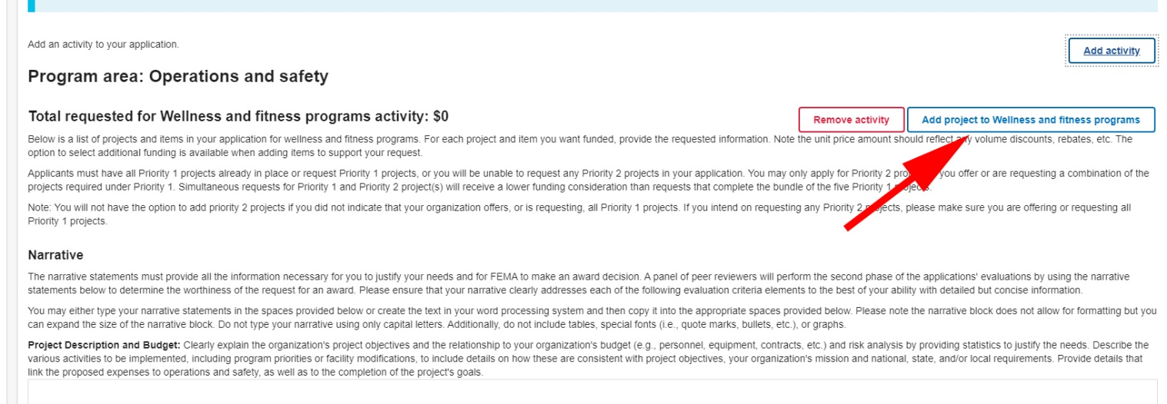

- Select “IAFF or IAFC peer fitness trainer program(s)”

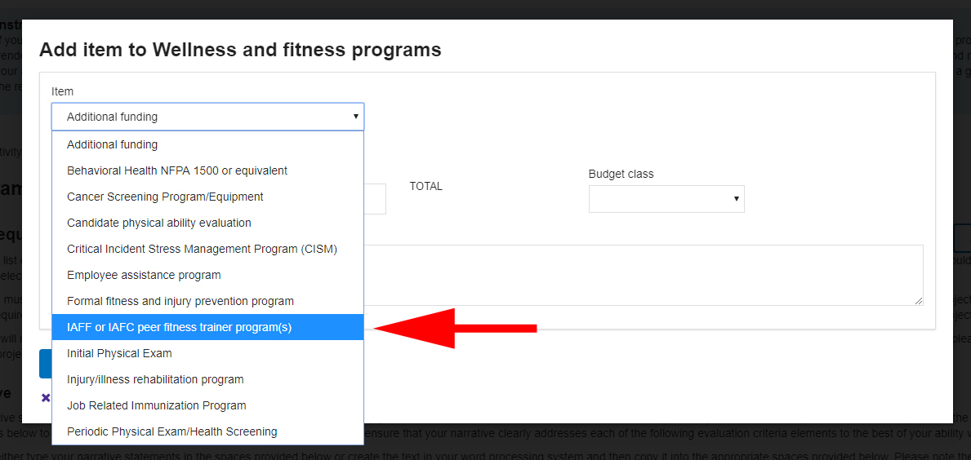
Answer questions:
- Do you offer this program?
- Will it be mandatory?
- Will it be open to all?
- Then click the “Add Item to IAFF or IAFC peer fitness trainer program(s)”
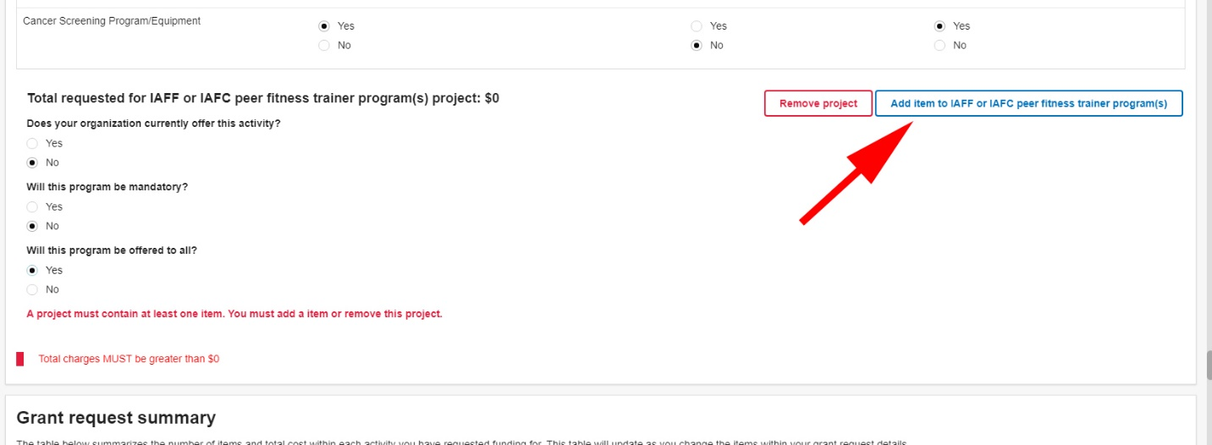
- Select Physical Trainers from the item dropdown box.
- Object Class: Contractual
- Number of units:
  - Number of units would be 25 people at a rate of $1,000/person, total $25,000 per class if all are members of your department
    - If you have less than 25 people and are going to open the extra spots to other departments, put the number of units as 1 and the cost as $25,000. You must explain that you are opening this program to other departments. Remember - proposed training projects that benefit the highest percentage of applicable personnel within a fire department or that will be open to other departments in the region receive a highly competitive advantage.

- You will have 500 characters to describe the program and costs. Items to consider:
  - Program includes: Instructor lead Train-the-Trainer program, manuals, curriculum, course materials, exam administration.
  - Peer Fitness Trainer Certificate
  - 40 hours of training over 5 days
  - Attendees will improve their ability to assess, design, implement and evaluate exercise sessions for fire fighters with varying interests — as well as have the knowledge and skills to become fitness and wellness leaders within their department.

To add exercise equipment:
- Click the “Add Item to IAFF or IAFC peer fitness trainer program(s)” button.
- Select the appropriate choices and object class
- You have 500 characters to explain your request

To add Additional Funding for overtime or backfill or another Wellness and Fitness project, click the “Add Project to Wellness and Fitness Program” button above the Narrative Sections and select “Additional Funding”
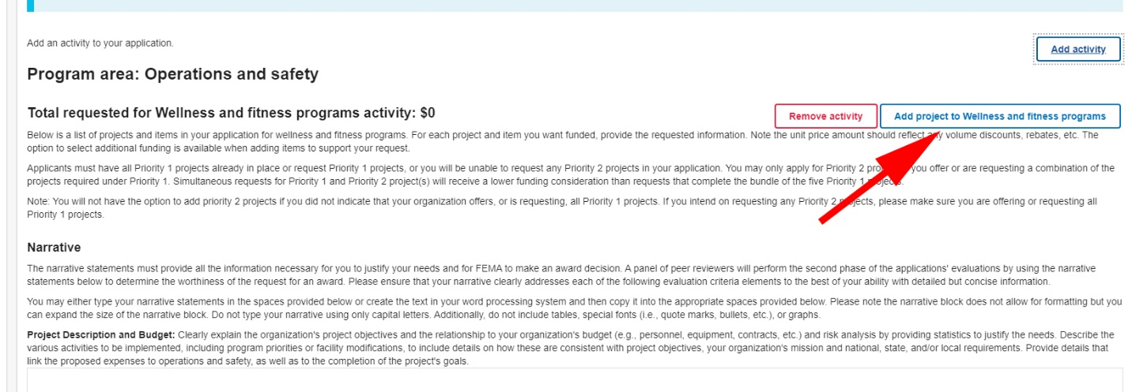
Eligible uses of training funds include, but are not limited to:
- Tuition, exam/course fees, and certifications/certification expenses
- Purchase of training curricula and training services (instructors)
- Overtime expenses paid to career fire fighters to attend training or to cover colleagues who are in training
- Cost for qualified behavioral health experts to provide continued clinical training/consultation
Under the Additional Funding category, you can add the cost of personnel attending the training and/or other costs to conduct this training. You will have 500 characters to explain your request. The more detail you provide on the requested funds, the better understanding the reviewers will have of your request.
  - If you are requesting the cost for personnel to attend training or to cover colleagues who are in training, be sure to include the number of personnel x the number of hours x the hourly rate. Explain the need for the personnel costs which may include the need to maintain minimum response capabilities during the scheduled training.

Go Back and Fill in the Main Narrative Sections

Project Description and Budget: Clearly explain the organization's project objectives and the relationship to your organization's budget (e.g., personnel, equipment, contracts, etc.) and risk analysis by providing statistics to justify the needs. Describe the various activities to be implemented, including program priorities or facility modifications, to include details on how these are consistent with project objectives, your organization's mission and national, state, and/or local requirements. Provide details that link the proposed expenses to operations and safety, as well as to the completion of the project's goals. You are limited to 4,000 characters.

Clearly identify all aspects of the project and project budget.
- Identify the problem, solution, and cost.
- Describe how the project aligns with program priorities.
- Demonstrate that the project will be completed within the 1-year period of performance.
- Mention that the grant is combined effort of management and labor.
  - Include IAFF local # and the city/town

Discuss:
- The IAFF PFT Guide can be located here for program specifics
- The extreme physical demands and stress of fire fighting
- Line-of-Duty deaths and injuries
- The need for a wellness program and how it will improve fire fighter health, wellness and safety
- Create a working environment conducive to maintaining healthy and physically fit fire fighters
- The need for baseline medical and physical assessments
- Significant cost savings in lost work time, workers compensation and disability
- The essential components of a wellness program
- What federal regulations or national standards are addressed with this training? Related National Fire Protection Association (NFPA) consensus standards including NFPA 1500, 1582 and 1583
- How the program will be delivered?
                - Peer Fitness Trainer (PFT), if applying for this program
- How many hours of training are included? (PFT = Mon-Fri 40hrs)
- Behavioral Health – management of health risk behaviors, training in behavioral skills, spirituality, financial planning, reactions to stress, mental illness, marriage and family issues
- EAP and CISM programs if applying for these priority 2 programs – refer to NFPA 1500
  - Written drug and alcohol policies
  - Education and counseling\
  - Support networks

Need to consider the following:
- Personnel Costs
- Need to explain how you will meet the mandatory match of the grant money being requested.

Cost Benefit: Describe how you plan to address the operations and personal safety needs of your organization, including cost effectiveness and sharing assets. The Operations and Safety Cost Benefit statement should also include details about gaining the maximum benefits from grant funding by citing reasonable or required costs, such as specific overhead and administrative costs. The request should also be consistent with your organization's mission and identify how funding will benefit your organization and affected personnel. You will be limited to 4,000 characters.
Discuss:
- Wellness Program cost justification
- Why a wellness fitness program is critical to members and the community first responders protect
- Number of residents who will be better protected
- Reduce worker’s comp claims and lost workdays
- Data collection – justification for implementing new programs
- Positive return on investment (ROI)
- Program evaluation methods
- What have been the department’s costs associated with physical fitness? (e.g., worker’s comp, disability claims, lost productivity)
- How will this training better prepare your members to assist fellow fire fighters during potentially traumatic events or large-scale disasters?
Personnel costs include:
- Overtime expenses paid to career fire fighters to attend training or to cover colleagues who are in training to maintain minimum response capabilities.
- Be sure to include the number of personnel x the number of hours x hourly rate.

Include a statement addressing impact and cost per person.
- Specify total number impacted (e.g., # in department)
- Divide total training cost by number impacted for cost per person.
- Provide a Break down per capita. (i.e. Cost / resident / fire fighter)

Statement of Effect on Operations: Explain how this funding request will enhance the organization's overall effectiveness. Describe how the grant award will improve daily operations and reduce the organization's risk(s) including how frequently the requested item(s) will be used and in what capacity. Indicate how the requested item(s) will help the community and increase the organization's ability to save additional lives and property. Jurisdictions that demonstrate their commitment and proactive posture to reducing fire risk, by explaining their code enforcement (to include Wildland Urban Interface code enforcement) and mitigation strategies (including whether or not the jurisdiction has a FEMA-approved mitigation strategy) may receive stronger consideration under this criterion. You will be limited to 4,000 characters.
Remember, the most important thing is for you to tell your story and why this funding and training are critical to your members and the community you protect. Additionally, proposed training projects that benefit the highest percentage of applicable personnel (your department and others) receive a higher rating and are more likely to be funded.
Include items such as:
- How it will improve operations
- How it will increase department viability
- Reduce risk
- Use and frequency of use
- Impact on fire fighter and public safety
- Have you had instances where the lack of physical fitness has led to a situation that could have been prevented?

For additional information on applying for grants, contact the IAFF Grants Department at FireGrants@iaff.org or (202) 737-8484.

For more information visit the IAFF’s Wellness-Fitness Initiative webpage and/or Peer Fitness Trainer Program webpage. Contact us by email at healthandsafety@iaff.org.

