[Your Letterhead]
For immediate release Contact: XXX
Nov. 12, 2023 XXX XXX-XXXX
[City] Fire Fighters, Paramedics Promote Crash Responder Safety Week
Nearly once every week, a first responder is killed while
attempting to clear a roadway crash.
[City] – As part of Crash Responder Safety Week (CRSW), Nov. 13-17, [Local Affiliate] are highlighting the critical role that each of us plays in keeping responders safe as they work to keep our roadways safe and clear.
“Roadside rescues are among the most dangerous emergency calls we handle, not just for drivers and their passengers but also for those of us clearing the roads,” says [Local President]. “We ask everyone on the road to please use extreme caution when passing the scene of an accident so we can all get home safe.”
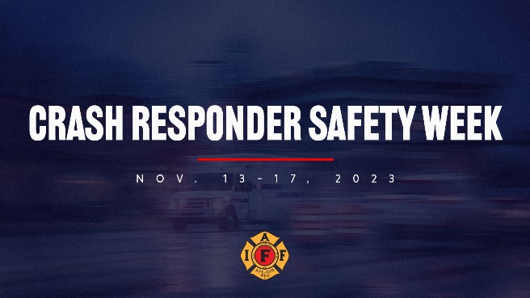
When responding to motor vehicle collisions, [Local Affiliate] works with emergency medical personnel, law enforcement, towing and recovery, public works, and safety service patrols to safely clear incidents. On any given day, approximately 50,000 traffic incident responders work roadside to provide emergency response and to restore safe travel after traffic incidents, such as crashes or spilled cargo.
Throughout Crash Responder Safety Week, the Federal Highway Administration collaborates with national partners, states, and local responders to reduce the number of traffic incident responders injured or killed in the line of duty.
This national event includes the promotion of state “Slow Down, Move Over” laws for motorists and free Traffic Incident Management (TIM) training for responders. For more information, visit iaff.org/toolkits/crash-responder-safety-week.
###

