[Your Letterhead]
For immediate release Contact: XXX
November 8, 2021 XXX XXX-XXXX
[City] Fire Fighters, Paramedics Promote Crash Responder Safety Week
Nearly once every week, a first responder is killed while
attempting to clear a roadway crash.
[City] – As part of Crash Responder Safety Week (CRSW) November 8-14, [Local Affiliate] is highlighting the critical role that each of us plays in keeping responders safe as they work to keep our roadways safe and clear.
“Roadside rescues are among the most dangerous emergency calls we handle, not just for drivers and their passengers but also for those of us clearing the roads,” says [Local President]. “We ask everyone on the road to please use extreme caution when passing the scene of an accident so we can all get home safe.”
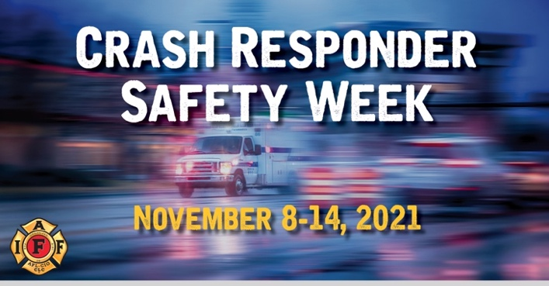
Throughout Crash Responder Safety Week, the Federal Highway Administration collaborates with national partners, states, and local responders to reduce the number of traffic incident responders injured or killed in the line of duty. From January through October of this year, 51 traffic incident responders have been killed, and far more sustained life-altering injuries.
[Affiliate Name] works every day with fire fighters, emergency medical personnel, law enforcement, towing and recovery, public works and safety service patrols]. Collectively, traffic incident responders work to assist all road users, applying well-rehearsed SOPs to provide emergency traffic control and to quickly clear incidents.
This national event promotes Slow Down, Move Over law awareness for motorists and free Traffic Incident Management (TIM) training for responders. For more information visit [Local Affiliate Website].
###

