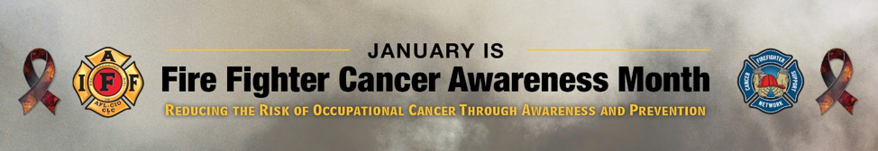
FOR IMMEDIATE RELEASE Contact: NAME
DATE EMAIL – PHONE NUMBER
January Dedicated as Fire Fighter Cancer Awareness Month
IAFF, FCSN set aside entire month to preventing occupational cancer
Research shows that fire fighters are more likely to be diagnosed with certain types of cancer than the general public – a trend that fire service organizations hope to reduce. The LOCAL NAME, an affiliate of the International Association of Fire Fighters (IAFF) and the Firefighter Cancer Support Network (FCSN) are partnering to deliver targeted education about best practices and resources to prevent and reduce cancer among fire fighters during Fire Fighter Cancer Awareness Month in January.
The month-long campaign includes safety stand downs, training briefs and a focus on prevention and mitigation, including the scope of the cancer in the fire service, best practices for prevention and skills to help survivors of occupational cancer.
These topics are reinforced with online resources, such as daily training information and infographics that promote the program and underline the importance of the issue on social media, as well as podcasts addressing the important issues of prevention and documentation of exposures to carcinogens.
"Ensuring the health and well-being of fire fighters is our top priority so we can keep our communities safe. We know that there needs to be further education, more assistance and resources for fire fighters when it comes to navigating an occupational cancer diagnosis,” says LOCAL FCSN REP. ”Working together with such dedicated groups, there is no doubt that this partnership will increase awareness and save lives."
“Our members are being diagnosed with cancer as a result of on-the-job exposures. We have had the sad duty of adding far too many of their names to the walls of our Fallen Fire Fighter Memorial,” says LOCAL PRESIDENT. “That’s why we have partnered with the FCSN to establish January as Fire Fighter Cancer Awareness Month – to give our hard-working members the most up-to-date guidance and data that will allow them the opportunity to enjoy a long, safe career and a healthy retirement.”
#####

