FFA Vehicle Specifications

Canteen Unit (S-747)  2005 Chevrolet C5500 Chassis 19,500 GVW  8.1L VORTEC 8100 MD Gasoline V8, 325 HP 450 LB FT Torque  Allison 1000 Series Automatic overdrive Transmission  60 Gallon Fuel Tank  18’ Integral aluminum body built by Krammes Kustom Body in St. Clair, Pa  NFPA Compliant Lighting Package  Back-up camera w/microphone  Dual Onan 7k Generators  True GDM-33C Refrigerator holds 300 bottles of Gatorade and Water  True Freezer  (2) Bunn Single coffee shuttle server system  50 Gallon Potable water tank with 3.3 gpm water pump  (2) Commercial Microwaves  Awnings on both sides of unit  Portable misting fan (Schaefer Mighty Mister)  10’x10’ Pop-up tent  Folding Chairs  10 Gallon portable drinking fountain  (2) 500 Watt Kwik-Raze Tripod Lights  (4) Cambro’s with 2 in Compartment accessable from the exterior | 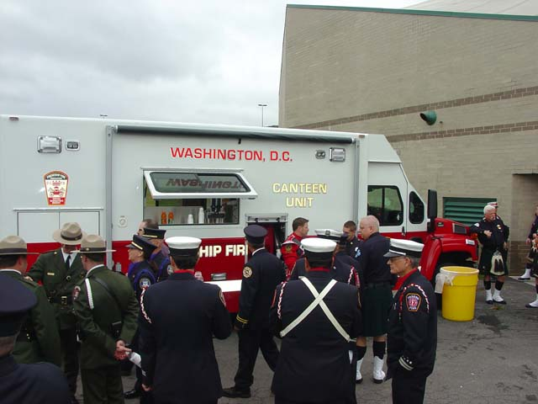  New Canteen at National Fallen Firefighters memorial.  Photo by Chris Oliphant

Rehab Unit (S-727)  2005 Chevrolet C5500 Chassis 19,500 GVW  8.1L VORTEC 8100 MD Gasoline V8, 325 HP 450 LB FT Torque  Allison 1000 Series Automatic overdrive Transmission  60 Gallon Fuel Tank  18’ Integral aluminum body built by Krammes Kustom Body in St. Clair, PA  NFPA Compliant Lighting Package  Back-up camera  (1) Onan 7k Generator  Beverage-Air Refrigerator holds 300 bottles of Gatorade and water  50 Gallon Potable water tank with 3.3 gpm water pump  Exterior isolated bathroom with recirculating toilet and Hand pump sink  Fixed exterior misting system with Scheafer high-pressure pump  Exterior bench seating  Awings on both sides of unit  Portable misting fan (Schaefer Mighty Mister)  10’x10’ Pop-up tent  Folding Chairs  10 Gallon portable drinking fountain  (1) Commercial Microwave  (2) 500 Watt Kwik-Raze Tripod Lights  (2) Cambros | 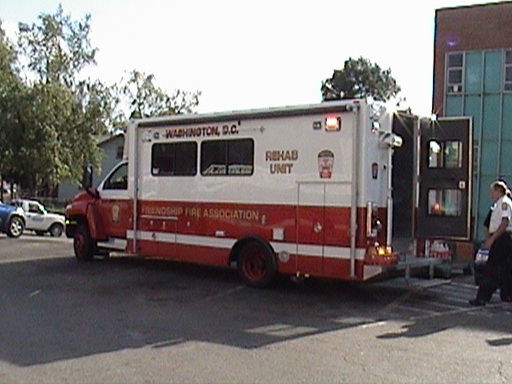  First run for new Rehab Unit: 2nd Alarm 2375 Bladensburg Road NE 10/15/05.  Photo by Vito Maggiolo

Old Canteen Unit - Serial# S701  - 1988 Chevy P30/Carlin Industries  - 350cid gasoline engine  - 3-speed automatic transmission  - 12kw Onan diesel generator  - 35gal fresh water tank  - 50gal waste tank  - Stainless steel interior  - Top-load refrigerator - 150 bottles water; 180 bottles Gatorade  - One commercial microwave oven  - 15gal electric coffee urn  - One Bunn coffee-maker  - One sink with water pump  - One Cool Draft misting fan  - 20gal portable ice chest  - 5gal Igloo/Cambro drink coolers  - Assorted rehab/medical supplies  - This unit has been donated to the D.C. Metropolitan Police Department for use at law enforcement incidents.
  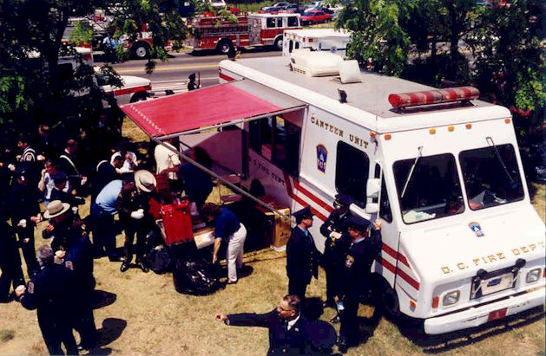
  In service at Memorial Service for D.C. Firefighters killed in line of duty, June 6, 1999. Photo by Walter Gold, FFA.
  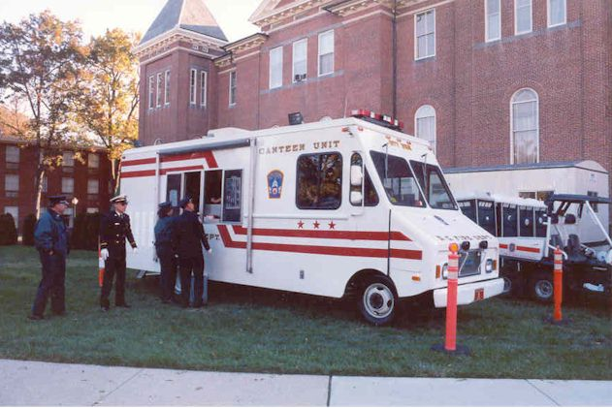
  In Service at Fallen Firefighters' Memorial, October 7, 2001. Photo by Todd Bianchi, FFA.

Old Rehab Bus - Serial# S761  - 1991 Ford E350/El Dorado Bus  - Diesel Engine  - Automatic overdrive transmission  - Perimeter seating/two a/c units  - "Mini-lator" Oxygen manifold system  - One Cool Draft misting fan  - 100 bottles Gatorade  - 64 bottles water  - 20gal portable ice chest  - Two Cambro 5gal drink coolers  - Assorted Rehab/medical supplies  - This unit has been sold to a southern fire department for continued use as a rehab unit.
  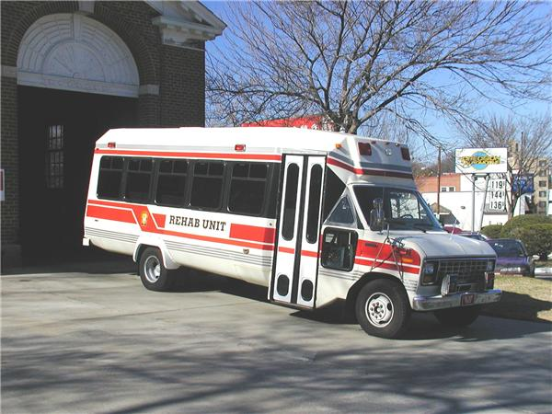
  Rehab Bus, Photo by Curt Elie, FFA
Rehab Support Unit - Serial# S502  - 1982 Chevy P-30 Grumman/Olsen  - 350cid gasoline engine  - 3-speed automatic transmission  - Custom build-out by DCF/EMS Fleet Maintenance Division  - One commercial microwave  - Two Igloo 12-volt coolers - 32 bottles water, 48 bottles Gatorade  - Four Cambro 5gal drink coolers  - One 5gal coffee urn  - 6.5kw Honda gasoline generator  - Four "Captains" seats
  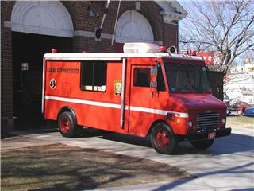
  Rehab Support Unit, Photo by Curt Elie, FFA
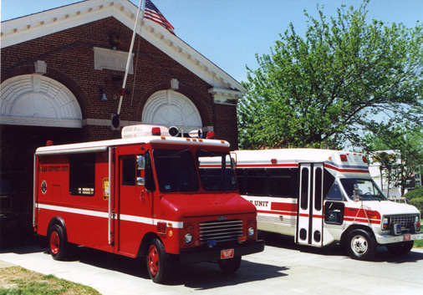
Units on the apron of Engine Co. 31. Photo by Curt Elie, FFA

Reserve Canteen Unit - Serial# S710  - 1972 Ford/Boyertown Step Van  - 289 I6 gasoline engine  - 3-speed automatic transmission  - Custom build-out by DCF/EMS Fleet Maintenance Division in 1972  - 6kw Onan gasoline generator  - One 15gal propane coffee urn  - One 4-burner propane cook-top  - One commercial microwave  - One dorm-style refrigerator - 80 bottles Gatorade  - Three 5gal Igloo drink coolers  - One sink/water pump/fresh water tank | Picture Not Available of Reserve Canteen Unit
The Canteen Units and the Rehab Support Unit are stocked with bottled Gatorade, bottled water, assorted doughnuts, coffee, hot chocolate, beef broth, chicken broth, beef stew, assorted chips, assorted snacks, Powerade mix.

