Kirwan Heights Vol. Fire Department
1200 Washington Pike - Collier Township, Pennsylvania 15017 - (412) 221-8382 - STA124770@aol.com

Rehabilitation Sector Guideline

Purpose: To provide medical observation and rehabilitation to personnel on fire grounds, EMS scenes, and training operations. Victims on such scenes may be evaluated at the rehabilitation sector.

Scope: This guideline is to be followed by all members of this department. The Incident commander has full control of the scene; he/she is solely responsible for any deviation from this guideline.

General: To ensure that the physical and mental condition of the member operating at the scene of an emergency or a training exercise does not deteriorate to a point that affects the safety of each member or that jeopardizes the safety and integrity of the operation the following guidelines need to be followed.

Rehab Sector Operations

Fire and EMS personnel involved in fire ground operations at the scene of an incident should be evaluated at a Rehab Sector. In most cases, using two air cylinders or at 45 minute to one-hour intervals, crews will be rotated through the Rehab sector for rest, evaluation and treatment.

The incident commander will determine when to establish a Rehab medical sector, and when crews will be assigned to replaced crews are to report to the Sector. The accountability officer will be in communication with the Incident Commander and the Rehab Sector to assign relief or back-up crews to replace crews that are going to Rehab.

Crews reporting to Rehab should check-in with the Rehab Sector Officer or other medical personnel. Rehab will be stationed away from the incident and running apparatus that are emitting any toxic fumes. The Rehab sector should be located in a safe environment were crews can remove their PPE and their vital signs can be checked. Vital signs are to be checked by EMS personnel and recorded (Rehab Sector worksheet) usually at ten-minute intervals, unless the vitals are critical. Vitals are to be checked a minimum of twice while at Rehab. If food area (Salvation Army) is set up, crews should be checked before and after going to this area.

Kirwan Heights Vol. Fire Department
1200 Washington Pike - Collier Township, Pennsylvania 15017 - (412) 221-8382 - STA124770@aol.com

Rehab Sector Operations (continuation)

Pennsylvania State Department of Health Medical Protocols and standing orders having jurisdiction over all personnel exhibiting signs of illness or injury. Any person complaining of chest pain, shortness of breath, or found to have abnormal vital signs, will be removed from active duty for further evaluation.

Chest pain follow PADOH protocol 5001

Shortness of breath follow PADOH protocol 4022, 8031

Dehydration follow PADOH protocol 6086, 7005

In these cases, the person will be treated and transported to the appropriate hospital per Incident Command.

After a fifteen to twenty minute rest personnel evaluations are within normal range, the Incident Commander will be advised of the crew’s available for reassignment.

The use of the Personnel Accountability System shall include units or teams assigned to the Rehab sector.

Points of Importance

The Incident Commander should take extreme weather situations into consideration and plan early for relief crews and for crew rotation into Rehab.

Kirwan Heights Vol. Fire Department
1200 Washington Pike - Collier Township, Pennsylvania 15017 - (412) 221-8382 - STA124770@aol.com

Extreme Weather Considerations

Heat over 80° F (actual heat index) - Rehydration fluids on hand.
(Replace fluid and electrolyte deficit)
- Cooling chairs and vests in operation.
- Shade tent or other structure established for Rehab Sector use.
- Notify the Salvation Army for support.

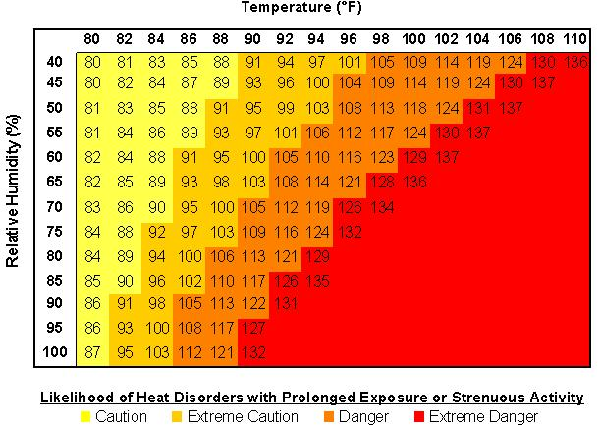

Kirwan Heights Vol. Fire Department
1200 Washington Pike - Collier Township, Pennsylvania 15017 - (412) 221-8382 - STA124770@aol.com

Extreme Weather Considerations

Cold weather below 40° F (keep wind chill factor in consideration)
- Rehydration fluids on hand.
(Replace fluid and electrolyte deficit)
- Enclosed tent or other structure established (public transportation bus)
- Notify the Salvation Army for support.
- Remove all wet PPE and have drying towels on hand.

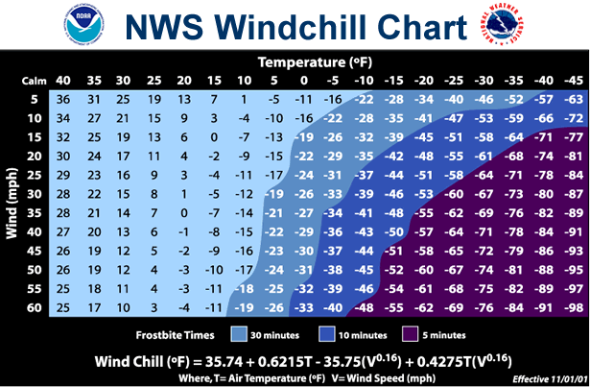

Kirwan Heights Vol. Fire Department
1200 Washington Pike - Collier Township, Pennsylvania 15017 - (412) 221-8382 - STA124770@aol.com

Points of Importance (continuation)

Firefighting crews should be cycled through Rehab on a regular basis.

Crews should be assigned intact and stay together.

Crews at Rehab should receive medical evaluation; blood pressure, heart rate, and respiratory rate, fluid, food, and rest.

All operating sectors should maintain an ongoing awareness of the condition of their personnel and use the Rehab Sector to combat excessive fatigue and exhaustion.

Personnel on the scene will get evaluated at least once.

Medical/Rehab Sector – Responsibilities

The Incident Commander shall be responsible for considering the circumstances of each incident and for making available adequate provisions for the rest and rehabilitation for all emergency workers.

Fire Officers shall maintain an awareness of the condition of each member operating within their span of control and ensure that adequate measures are taken to provide for their safety and health. The fire officer shall use the ICS to request relief and reassignment of fatigued crew members.

During periods of extremely hot weather and before any extended training exercise, personnel are encouraged to pre-hydrate. In addition, all personnel while operating at scenes should take all opportunities to rehydrate themselves as often as possible.

Personnel assigned to operate the Rehab Sector will be responsible for several activities within the sector and will maintain a high profile and remain within 10 feet of the sector at all times.

Primarily, the flow of personnel into and out of the sector will need to be coordinated and recorded. The initial set up should be located at or around an ALS unit (Medic/Rehab 773), tent should be deployed to stay out of the weather.

EMS personnel assigned to the Rehab Sector will be responsible for obtaining vital signs of firefighters as they are assigned to rotate through Rehab. Vital assessment kits(BP cuff, stethoscope, Pulse OX, and Rehab sector worksheet) will be made available.
Kirwan Heights Vol. Fire Department
1200 Washington Pike - Collier Township, Pennsylvania 15017 - (412) 221-8382 - STA124770@aol.com

Medical/Rehab Sector – Responsibilities (continuation)

When weather permits, a table will be put in place, and all the following items will be placed on it: bottled water, container of liquid concentrate Gatorade, cups, ALS and BLS equipment. (under table) If weather does not permit these items may be kept in the medic unit or under other cover. On hot weather days the misting fans are to be located outside the rehab tent in an open area with seating in front of them. (persons entering rehab) The cooling vests are to be set up for personnel having their vitals assessed in the Rehab Sector. Forearm submersion chairs are to be placed in the relax area for personnel waiting to have their vitals reassessed.

A running tally of crews in Rehab and those who are available for reassignment must be kept available at all times.

In ideal situations, crews should have 15 to 20 minutes to spend in Rehab. Fluid replacement should be high priority and available for crews when they are in Rehab.

When involved in firefighting operations, crews should be given only electrolyte enriched water during the first hour.

During cold weather operations, warm drinks should be offered by support crews (Salvation Army) and only taken in moderation.

Smoking is not allowed in or near the Rehab Sector area.

Kirwan Heights Vol. Fire Department
1200 Washington Pike - Collier Township, Pennsylvania 15017 - (412) 221-8382 - STA124770@aol.com

Vital Sign Guidelines

When firefighting crews arrive at the Rehab Sector they should be instructed to remove PPE as deemed necessary and a complete set of vitals is to be taken,

The following criterion is to be used in the evaluation of fire ground personnel during a Fire or EMS incident. Keep in mind that Medical Protocols and Standing Orders, having jurisdiction, supersedes the guidelines listed below.

● If the diastolic blood pressure is > 130 the firefighter must be transported to the hospital for evaluation.

● If the diastolic blood pressure is >100 and <130 the firefighter will be given up to two 20 minute rest periods. If the diastolic blood pressure remains >100 and <130 the firefighter should be transported to the hospital for evaluation. If the firefighter shows no serious signs of illness or their normal vital trend falls within this range the medical provider should use their best clinical judgment as to whether or not transport is necessary. Medical command should be consulted to determine best course of action if the provider is unsure or uncomfortable with allowing the firefighter to return to duty.

● If the systolic blood pressure is > 200 the firefighter must be transported to the hospital for evaluation.

● If the systolic blood pressure is >150 and <200 the firefighter will be given up to two 20 minute rest periods. If the systolic blood pressure remains >150 and <200 the firefighter should be transported to the hospital. If the firefighter shows no serious signs of illness or their normal vital trend falls within this range the medical provider should use their best clinical judgment as to whether or not transport is necessary. Medical command should be consulted to determine best course of action if the provider is unsure or uncomfortable with allowing the firefighter to return to duty.

● If the heart rate is >200 the firefighter must be transported to the hospital.

● If the heart rate is between >140 and <200 the firefighter will be given up to two 20 minute rest periods. If the heart rate remains >140 and <200 the firefighter should be transported to the hospital. If the firefighter shows no serious signs of illness or their normal vital trend falls within this range the medical provider should use their best clinical judgment as to whether or not transport is necessary. Medical command should be consulted to determine best course of action if the provider is unsure or uncomfortable with allowing the firefighter to return to duty.
Kirwan Heights Vol. Fire Department
1200 Washington Pike - Collier Township, Pennsylvania 15017 - (412) 221-8382 - STA124770@aol.com

Vital Sign Guidelines (continuation)

● If the respiratory rate is >30 or <10 the firefighter must be transported to the hospital for evaluation.

● If the respiratory rate is >20 and <30 the firefighter will be given up to two 20 minute rest periods with supplemental oxygen. If the respiratory rate remains >20 and <30 the firefighter should be transported to the hospital for evaluation. If the firefighter shows no serious signs of illness and does not appear to having an acute respiratory event or their normal vital trend falls within this range the medical provider should use their best clinical judgment as to whether or not transport is necessary. Medical command should be consulted to determine best course of action if the provider is unsure or uncomfortable with allowing the firefighter to return to duty.

● If the temperature is > 100.6° F the firefighter will be required to utilize either the forearm submersion chair or the cooling vest system. The firefighter’s temperature will be reassessed at 20 minute intervals. If the temperature remains >100.6° F after two 20 minute active cooling periods they should be transported to the hospital for evaluation of heat related illness.

● If the temperature is < 100.6° F the firefighter may return to duty unless they exhibit the signs and symptoms of heat related illness.

● In all cases, irregardless of vital sign evaluation, any firefighter displaying the physiologic signs of a serious medical condition as determined by the medical crew must be transported for evaluation.

EMS/Fire Rehab Personnel Reports

EMS/Fire Rehab report is to be completed on all personnel being evaluated at the scene. The appropriate patient care report should be completed when a firefighter is transported or when a firefighter requires transport but refuses.

Signs and Symptoms Checklist should be completed for all illnesses, injury, or medical problems.

