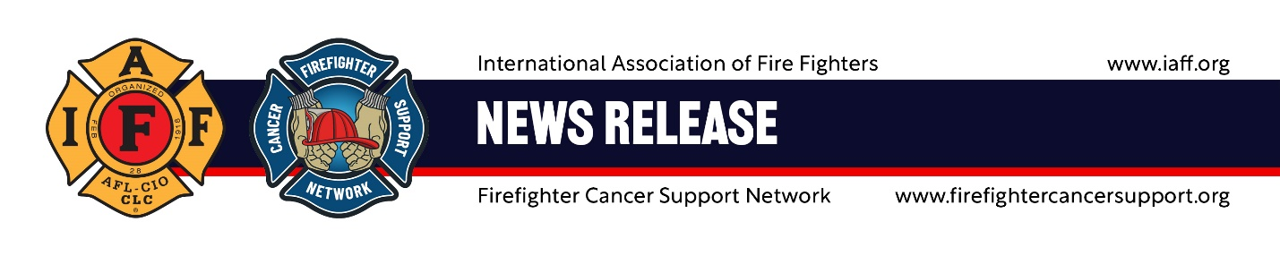
For immediate release Contact: Tim Burn, 202-230-7167; tburn@iaff.org
Tuesday, Jan. 6, 2026 Russ Osgood; rosgood@fcn.net

Fire Fighters Take Aim at Occupational Cancer
January is Fire Fighter Cancer Awareness Month, when leading fire service organizations come together to provide education, prevention strategies, and support for fire fighters facing cancer.
Occupational cancer claims more fire fighters’ lives than any other cause – surpassing fires and other on-scene incidents. The International Association of Fire Fighters (IAFF) and the Firefighter Cancer Support Network (FCSN) are committed to changing that.
During Fire Fighter Cancer Awareness Month this January (iaff.org/cancer-awareness-month), the IAFF and FCSN will deliver targeted education and best practices and resources to reduce the risk for fire fighters at every stage of their careers.
This year’s Fire Fighter Cancer Awareness Month focuses on understanding occupational exposures, the importance of screening and early detection, wellness and lifestyle practices that support prevention, and navigating the challenges of a cancer diagnosis.
“Fire fighters know our job comes with risk. But we should never accept cancer as an inevitable consequence of our profession,” says IAFF General President Edward Kelly. “The IAFF and FCSN stand together in our commitment to give fire fighters the tools to protect themselves and win this fight.”
“It’s a heartbreaking reality that the title of fire fighter comes with a far greater risk of developing occupational cancer than most people will ever know,” says Lisa Raggio, CEO of FCSN. “For 20 years, FCSN has stood beside fire fighters and their families in their darkest moments while educating fire fighters throughout the country on reducing their risk of a cancer diagnosis, offering hope, guidance, and the reassurance that they are never alone. The push for greater awareness and education around occupational cancer is not just important; it is lifesaving. We are deeply proud to stand with the IAFF, an organization that continues to fight fiercely for the health, safety, and futures of the men and women who sacrifice so much for their communities.”
About the Firefighter Cancer Support Network
Firefighter Cancer Support Network (FCSN) provides critical assistance for career or volunteer, active or retired fire fighters, emergency medical service providers, and their immediate family members who have been diagnosed with cancer. They deliver valuable post-diagnosis resources followed by unique badge to badge, one-on-one mentorship from one of their 220 fire-service mentors who have first-hand knowledge about battling cancer. They share their survivor’s journey about their types of cancer, their own experiences with testing and treatments, and offer valuable insight into the recovery process. firefightercancersupport.org
About the International Association of Fire Fighters
The International Association of Fire Fighters (IAFF) is the driving force behind nearly every advance in the fire and emergency services in the 21st century. Representing over 362,000 professional fire fighters, emergency medical workers, and rescue workers, IAFF members protect more than 85 percent of the population throughout the United States and Canada. www.IAFF.org.

