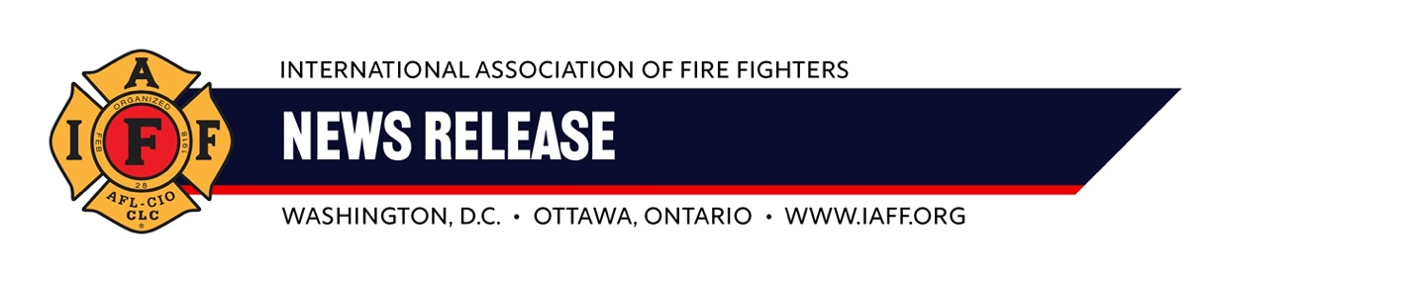For immediate release Contact: Tim Burn
Friday, November 8, 2024 202 230-7167; tburn@iaff.org

Fire Departments Don’t Just Honor Veterans,
They Hire Them

(Journalists: as Veterans Day approaches consider a story about the many veterans who return home to become fire fighters. We can help you tell this story.)
Did you know that more than 20 percent of all fire fighters and paramedics are military veterans? In some cities, most of the fire fighters have served their country in the military.
Fire fighters and paramedics have a unique understanding and admiration for those who have served or are currently serving in the military. They honor them not just on Veterans Day, but every day.
Veterans make excellent fire fighters because they understand the call to serve, they are equipped mentally and physically to put their own safety at risk to protect others, and they are comfortable with the rigid command structure in fire departments.
Contact Tim Burn, (202 230-7167; tburn@iaff.org) if you would like to do a story on military veterans who have taken the call to serve back home to be fire fighters.
###

