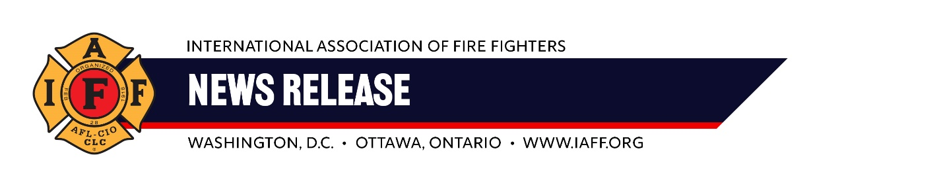
For immediate release Contact: Ryan Heffernan
Sunday, July 21, 2024 rheffernan@iaff.org / 202-374-9484

The following is a statement from IAFF General President Edward A. Kelly:

“Past, present, and future fire fighters are better off because of Joe Biden.
“For nearly 50 years, he has been a champion of the IAFF. His work has directly led to the hiring of tens of thousands of fire fighters, safety improvements in this most dangerous of jobs, and a nation that is now aware of the toxic threats we face every time we put on our gear. And, when a fire fighter makes the ultimate sacrifice, President Biden’s work has ensured their families receive the benefits they deserve.
“He is undoubtedly the greatest President fire fighters and emergency medical workers have ever had. Our membership – and the communities we serve – will forever be in his debt.
“The International Association of Fire Fighters (IAFF) is the labor union representing fire fighters and emergency medical workers. Our nearly 350,000 members protect over 85% of the population across the United States and Canada.”
###

