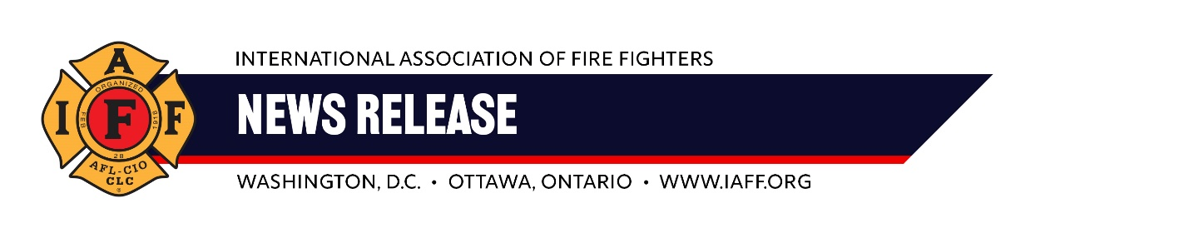
For Immediate Release Contact: Ryan Heffernan
Friday, Sept. 13, 2024 202 374-9484; rheffernan@iaff.org
Statement from IAFF General President Edward Kelly on reduction of Aurora paramedic’s sentence:

“Judge Mark Warner’s decision acknowledges the challenges paramedics face when making split-second medical decisions. While nothing can undo the tragic events of Mr. McClain’s death, the IAFF is relieved that the court recognized the need for fairness and justice in this case. Peter Cichuniec did not belong behind bars. Our union has stood with Pete throughout this difficult process, and we will continue to support him and Brother Jeremy Cooper as they fight for the reversal of what we believe to be unjust convictions. The IAFF will always prioritize and advocate for the public's safety and our members' ability to do their jobs without fear of ill-conceived criminal prosecution.”
– Edward A. Kelly, General President, International Association of Fire Fighters
ABOUT THE IAFF
The International Association of Fire Fighters (IAFF) is the driving force behind every advance in the fire and emergency services in the 21st century. With headquarters in Washington, D.C., and Ottawa, Ontario, the IAFF represents over 350,000 professional fire fighters, emergency medical workers, and rescue workers. Our members protect more than 85 percent of the population throughout the United States and Canada.
###

