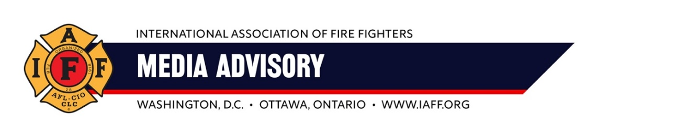
For Immediate Release Contacts:
Thursday, May 30 2024 Tim Burn: (202) 230-7167; tburn@iaff.org
Matt Lowery: (206) 715-6839; mlowery@iaff.org

Boeing Fire Fighters Local I-66 Members Vote to Ratify Boeing Contract Agreement

RENTON, WASHINGTON — IAFF Boeing Fire Fighters Local I-66 members voted to ratify the latest tentative contract offer. The final vote tally was 86 in favor and 24 opposed. With the contract approved, the firefighters who protect Boeing Co's Washington State facilities expect to return to work on Saturday.
"Boeing Local I-66 fire fighters stood tall in the face of a multi-billion-dollar company trying to break their ranks. The entirety of the Labor Movement stood with them, as did President Joe Biden, who called on Boeing to give fire fighters better pay and benefits," said IAFF General President Edward Kelly. "We’re grateful our rank-and-file members got the contract they deserve, one that provides them with fair pay for their critical work. This is why collective bargaining matters – it gives workers a voice at the table and strengthens our country’s middle class."
ABOUT THE IAFF
The International Association of Fire Fighters (IAFF) is the driving force behind every advance in fire and emergency services in the 21st century. With headquarters in Washington, D.C., and Ottawa, Ontario, the IAFF represents nearly 350,000 professional firefighters, emergency medical workers, and rescue workers. Our members protect more than 85 percent of the United States and Canada’s population.
###

