 |  | 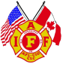
  Fairfax County Fire & Rescue Department
   Wellness Fitness Newsletter
  Spring - 2009

Previous editions of the Wellness Fitness Newsletter have focused on injuries, injury prevention and exercise. This edition will shed light on controllable behaviors that place your health in danger. The first item, tobacco use, is of special interest, especially to our department. It was 25 years ago, March 12, 1984, that all new members hired after that date agreed as a condition of employment to comply with Rule and Regulation # 200.16

200.16 Smoking On or Off Duty
Uniformed employees hired on or after March 12, 1984, shall not smoke at any time on
or off duty. Uniformed employees hired on or after June 8, 1998, shall not use nicotine products at any time on or off duty.

This represents an entire career or generation of firefighters that do not smoke. This is an awesome rule that took courage from the leadership to enact at the time in a state that is still famous for tobacco as a cash crop. Ironically, the Commonwealth is finally (25 years later) banning smoking in all public restaurants. This law signed by Governor Kaine, goes into effect December 1, 2009.

How much better is our health because of this rule? How many lives have been saved and/or are cancer free because of this stance on smoking? In an upcoming Line Copy article, we will look at the effects of smoking on our department.

If you still smoke and would like to quit, please call upon Health Programs for assistance. It is never too late and the effects are immediate!!

Management of Health Risk Behaviors

Some aspects of wellness are outside of our control. For instance, our genetic profile is something we are born with, and we are not able to change our genes themselves. Some people are born with a vulnerability to back troubles, addiction, or depression. However, even with a genetic profile that makes someone vulnerable to a problem, many of the behaviors that are under our control determine whether an illness will result. Therefore, learning how to manage health risk behaviors is tremendously important.

The health risk behaviors discussed are:

- Tobacco Use
- Drugs and Alcohol Use
- Sedentary Lifestyle
- Poor Nutrition

Remember, health risk behaviors frequently affect not only the fire fighter, but also his or her family, friends, co-workers and community. Making a positive change from a negative lifestyle to a healthy lifestyle can benefit the firefighter and all those in his or her network.

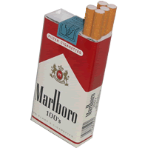
Tobacco Use
There is good news in the area of tobacco use. In general, the number of people who are still using tobacco products is declining. That is, people are quitting.

There is also bad news in the area of tobacco use. The number of young people who are starting to use tobacco seems to be rising.

Consider these facts:
- Cigarette smoking is the leading preventable cause of death in the United States, accounting for one of five deaths.
- Similarly, tobacco use is the primary cause of preventable disease and death in Canada (Canadian Center for Health and Disease, 2003).
- 22.5% of Americans smoke cigarettes.
- 23% of Canadian men smoke and 20% of Canadian women smoke.
- 5.5% of Americans smoke cigars.
- 6.5% of US men use smokeless tobacco products.

The consequences of tobacco use are very well documented, and are well known by most people, even those whose still use tobacco.
• More deaths are caused each year by tobacco use than by all deaths from HIV, illegal drug use, alcohol use, motor vehicle injuries, suicides and murders combined!
•There is no “safe” tobacco product; all have potential for harm.
•In addition, long before mortality issues, smokers experience health problems of much earlier onset, and interference such as bronchitis, high blood pressure, peripheral vascular disease and fertility issues.

What can you do, if you, or someone you care about, are still using tobacco?
•Behavioral Tobacco Cessation programs are available, and are usually covered by health insurances.
•Self-help programs such as Nicotine Anonymous are available at Nicotine Anonymous, Smokefree.gov
•Nicotine Replacement therapy and medications such as Zyban have demonstrated effectiveness, especially when used in conjunction with a behavioral program. (Mayo Clinic)

Remember, tobacco use is one of the most challenging behaviors to change once someone becomes a regular user. In addition, like a great many things that are hard to change, changing from tobacco dependent to tobacco free can have great rewards. People who quit reduce the risk of heart attack, lung disease and many cancers. In addition, they have the satisfaction of mastering an addiction that was perhaps more compelling to them than any other habit in their life. People who become quitters can set an important example for everyone in their network


Alcohol and Drug Use, Abuse and Dependence
Beverages containing alcohol are frequently considered one of life’s pleasures, and there are now some studies, which support that small doses of alcohol can have health benefits. In a similar vein, drugs delivered in the context of medical need and taken as prescribed, contribute to the common good.

In contrast, the use of alcohol and/or drugs can have negative consequences as well. We do not yet understand a great deal, about what causes someone to go from acceptable and appropriate use to abuse and or dependence. However, abuse and dependence are common among both Americans and Canadians.

For example, both the United States and Canada have research organizations funded by the government to study the problems of abuse and dependence. These agencies have developed estimates of the rate of drinking and drug use in the US and Canada.

For instance:
■ 54.9% of US adults report at least one alcoholic beverage per month.
■ 1 in 3 adult drinkers report past-month binge drinking, where a binge is defined as five or more drinks in one drinking occasion.
■ Binge drinkers are 14 times more likely to drink and drive than non-binge drinkers.
■ Heavy drinking (daily drinking of more than one drink per day for women and two drinks per day for men) is reported for approximately 6% of US citizens. Prevalence is higher for men (7.1%) than women (4.5%).
■ About 4% of the US population met criteria for alcohol dependence in the last year. In Canada, about 4% of men and 2% of women met alcohol or drug dependence criteria (CCHS, 2003).

When we look specifically at alcohol use among firefighters, we see that:
■ Studies of firefighters demonstrate that 29% of active duty fire fighters have possible or probable problems with alcohol use (Boxer and Wild, 1993).
■ 50% of the firefighters surveyed in Oklahoma City had a prior history of alcohol problems (North, 2002).

Defining the problem:
Alcohol and drug users frequently have a difficult time knowing if their use has crossed over the line into a health risk behavior. Therefore, the following definitions may be useful:

Heavy drinking is defined as daily drinking of more than one alcohol-containing beverage for women and more than two alcohol beverages for men.

Alcohol Abuse is defined as an unhealthy pattern of use with one or more of the following occurring within a 12-month period:
- Use resulting in failure to fulfill major work, school or home obligations.
- Recurrent use in situations in which it is hazardous.
- Recurrent alcohol related legal problems.
- Continued use despite knowledge of problems caused by or aggravated by use.

Alcohol dependence requires having three or more of the following symptoms in the past year (DSM-IV, 1994):
- Tolerance (needing more alcohol to become intoxicated)
- Withdrawal
- Alcohol use for periods longer than intended.
- Considerable time spent in obtaining or using alcohol, or recovering from its effects.
- The discontinuation or loss of important social, work, or recreational activities because of alcohol use.
- Continued use of alcohol despite knowledge of problems caused by or aggravated by use.

Definitions for problematic drug use include:
- Drug Misuse - defined as taking more than prescribed, for longer than prescribed. In the case of illegal substances, any use, by definition, is considered misuse.
- Drug Abuse - defined as an unhealthy pattern of use with one or more of the following occurring within a year:
- Use resulting in failure to fulfill major work, school or home obligations.
- Recurrent use in situations in which it is hazardous.
- Recurrent drug-related legal problems.
- Continued use despite knowledge of problems caused by or aggravated by use.

Drug dependence - defined as having three or more of the following symptoms in the past year (DSM-IV, 1994):
- Tolerance (needing more of the drug to become intoxicated)
- Withdrawal
- Drug use for periods longer than intended.
- Considerable time spent in obtaining or using the drug-of-choice, or recovering from its effects.
- The discontinuation or loss of important social, work, or recreational activities because of drug use.
- Continued use of drug despite knowledge of problems caused by or aggravated by use.

The consequences of alcohol and drug misuse can be extremely costly and painful. The following statistics illustrate these costs.

- Alcohol is the third leading cause of death in the US.
- 41% of all traffic related deaths are alcohol related.
- 31% of those who die from unintentional, non-traffic injuries in the US are intoxicated at the time of death.
- 40% of all crimes are committed under the influence of alcohol.
- 66% of victims of partner violence acknowledge that alcohol was involved in the incident.
- 50% of child abuse and neglect cases are linked with parental alcohol and drug abuse.
- 23% of suicides are attributable to alcohol.
- 40% of deaths from unspecified liver disease are attributable to heavy alcohol consumption.
- The risk of cancer increases with the amount of alcohol consumed.

As the list of consequences show, alcohol and drug abuse are not problems that are confined to the user; in fact, the people most affected by alcohol and drug problems may be those close to, or dependent on, the user (e.g., family, friends and coworkers). Thus, people who have crossed over into health risk from their alcohol and/or drug misuse should know that help is available, and the variety of effective help is increasing every year.

Firefighters who want to learn more about the types of help available can find excellent web resources at the National Institute of Health (www.nih.gov; www.nida.gov; www.niaaa.gov)

Recovering from alcohol and drug abuse problems can be done in many ways and in many venues. Research shows that most of the community-based self-help programs such as Alcoholics Anonymous or Narcotics Anonymous are helpful for a substantial group of people. Some people trying to change their alcohol or drug problems may require medical supervision for detoxification. Others can recover through setting a good behavioral plan with a mental health provider. Still others benefit from inpatient treatment. A growing number of medications seem to aid people in staying abstinent and/or controlling urges to use. For some, a comprehensive plan is necessary in which all or some of the preceding interventions are employed.

When alcohol and drugs impair a firefighter or someone he cares about, the ripple effects can be far-reaching. The IAFF stands firmly behind those in recovery from this problem, and encourages the use of local EAP representatives to facilitate treatment. Full resumption of family, work and social life is the reward that awaits those who successfully resolve alcohol and drug abuse and dependence.

In summary, firefighters who have alcohol and/or drug problems or who may have friends or family with alcohol and drug problems can access the following services:

Web based information for AA or EAP.

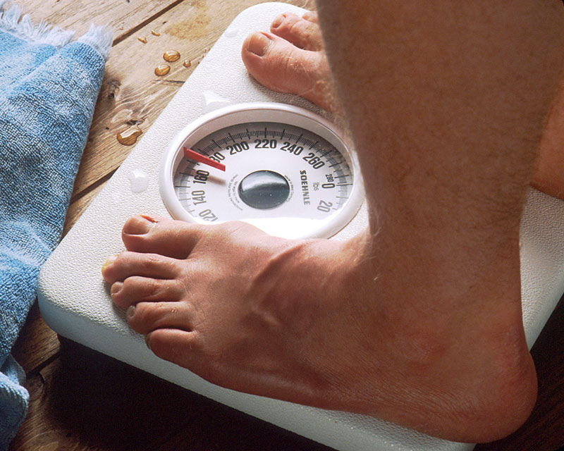
Sedentary Lifestyle
In the days in which farming was a typical occupation and factory work involved physical activity, the problem of sedentary lifestyle was quite rare. Today the majority of Americans report that they do not engage in regular physical activity of greater than 20 minutes duration at least three times a week. By that definition, most people are sedentary. To be more precise:

• 58% of US citizens are reported to have a sedentary lifestyle, making sedentary lifestyle the most prevalent modifiable risk factor for Coronary Heart Disease.
• Defined as irregular physical activity, as reported as less than three sessions of activity per week, or sessions of less than 20 minutes per occasion.

The consequences of sedentary lifestyle are obvious. Obesity, heart disease, colon cancer, diabetes and hypertension are linked to sedentary lifestyle. In addition, mood disorders are more common in those with sedentary lifestyle. Substance use and abuse is more common in those who are physically inactive. Overall, reversing a sedentary lifestyle is one of the most rewarding lifestyle changes a person can undertake. Initiation of exercise releases the body’s natural opioids; the phenomenon of runner’s high is well documented. In addition, becoming active can have nearly immediate reinforcing effects. Those who exercise, eat better, sleep better, have better moods, and better life satisfaction than those who are sedentary.

Myths about increasing physical activity are numerous, but do not let yourself be dissuaded by them. These myths include:

- Concern that one must exercise for over 30 minutes daily for the activity to make a difference.
- Concern that exercise must be costly (e.g., equipment, gym fees, personal trainers).
- Concern that exercise will result in some sort of injury.
- Concern that there are other activities that are more important.

We have just one response to those points: they are MYTHS!

- 20-30 minutes of walking per day, more days than not, will make a big difference.
- All one needs to walk is a decent pair of shoes.
- Walking is the least likely exercise to cause joint, back or muscle problems. A program of wellness is imperative for people to maintain fitness for life and fitness for duty.
- Interested firefighters are referred to the Health and Fitness Initiative of the IAFF for guidelines on physical fitness training.


Poor Nutrition
Nutrition is another arm of a behavioral health plan. It is considered a behavioral health issue because diet and nutrition effect how we look, feel, think and act. What we give our bodies for fuel predicts how well our body can perform emotionally, physically and cognitively.

In addition, every fire fighter knows that calories-in need to balance with calories-out, or a change in weight, and a change in function, will result. Overeating results in weight gain, which can result in decreased fitness for duty. Under eating results in weight loss, which can also decrease fitness for duty.

Specific guidelines for amount of foods eaten, types of foods eaten, and methods of maintaining a healthy diet have been established by organizations such as the:

American Dietetic Association
American Heart Association
Center for Disease Control, Healthy Eating Tips
Food and Nutrition Information Center

The consequences of poor nutrition are considerable. Surprisingly, some studies suggest that the majority of Americans are malnourished. Indeed, Americans (more than Canadians and Europeans) tend to be overweight and undernourished. Poor nutrition results in poor behavior, lower core strength, increased body fat, slower mental problem solving, less alertness, and slower muscle response time.

The National Institute of Health highlights the impact of poor nutrition on health:
- An estimated 65.2 percent of U.S. adults are overweight or obese, defined by having a body mass index of 25 or more (National Center for Health Statistics, 2003).
- 30.1% of US adults have hypertension (NCHS, 2002).
- Hypertension is called a silent killer, because it often goes undetected and untreated.
- High Cholesterol is a leading contributor to heart disease. A high blood level of low-density lipoprotein cholesterol (LDL) can lead to atherosclerosis. High cholesterol diets are common to Canadian and US citizens.

- Diabetes is estimated to affect 8% of the adult US population.
- Each year, more than 500,000 Americans die of heart disease. The single greatest cause of line-of-duty death in fire service is heart attack.
- Stroke occurs when a blockage or weakness in the circulatory system results in a bleeding event. The most common strokes occur in the brain, usually resulting in some degree of brain damage.
- Gallstones are deposits of minerals in the gall bladder that can result in significant pain when moving through the system. Some gallstones may require surgical interventions.
- Gout is a painful condition of the joints caused by an accumulation of uric acid, which results in crystals forming in the joints. Associated swelling can result in permanent joint damage. Poor diet is a leading contributor to the development of gout.
- Sleep apnea is the condition in which a sleeping person stops breathing for periods exceeding 20 seconds. The resulting lack of oxygen can trip off rhythm problems with the heart. People with sleep apnea are frequently not well rested, as the lack of oxygen results in frequent waking.
- Osteoarthritis is an inflammation of the joints, resulting in calcifications and breakdown of joint flexibility.
- Several types of cancer, particularly colon cancer, bladder cancer, and breast cancer may be affected by diet.
- Depression, eating disorders, and distorted body image are often associated with poor nutritional status.

What can someone do to alter his or her unhealthy eating patterns?

Nutritional Counseling is available and often covered by insurance. The local EAP representative should have a list of licensed counselors that understand the physical and mental demands placed on firefighters. Nutritional counselors can provide a complete analysis of your current diet, make suggestions for a healthier diet, and problem solve methods of achieving a healthy diet.

Exercise will aid in appetite management, and will maximize the number of calories you can consume while remaining healthy. Links between a healthy diet and exercise are discussed on www.acefitrness.org.
There are also a number of non-profit and for-profit weight management programs available. For example, a non-profit is the 12-step group Overeaters Anonymous (OA). Information on local branches of OA is found on www.oa.org.


Weight Watchers (www.weightwatchers.org) is a for-profit weight management program that has the longest history in the United States of helping adults modify their diets. Relative to other, less long-standing weight management programs, Weight Watchers is reasonably priced and seems focused on learning behavioral changes that will translate into longer-term success and modification.

Finally, there is a growing industry in medical interventions to manage eating habits. Stomach stapling procedures are expensive and controversial, with preliminary data indicating that although the weight loss can be significant, unless the person is morbidly obese, the procedure’s risks outweigh the benefits. Furthermore, unless a person learns healthier eating patterns and better food choices, the weight loss will not be permanent.


Physical Fitness

The IAFF has developed a Wellness-Fitness Manual that describes and gives suggestions for the assessment of medical fitness. The manual further lays out a framework for physical fitness training, with specific protocols. In addition, firefighters are encouraged to use gyms, local YMCAs, and personal training guides. On line, the American Council on Exercise has fitness facts available for downloading. The Centers for Disease Control offer free summaries of exercise facts that are interesting and inspiring.

Information in this article was gathered from the IAFF website.
www.iaff.org

