 | Fairfax County Fire & Rescue Department  Wellness Fitness Newsletter  Winter - 2008 |   

As we close out 2008 and look forward to 2009, it is time for all of us to resolve to find the time to better ourselves physically. According to a latest NIOSH report one million workers suffer back injuries each year. That works out to 1 in every 5 workplace injuries. Of those back injuries, 4 out of 5 are lower-back related. Back problems are the leading cause of disability for 30-45 year olds. Back injuries can happen at any age and at anytime without warning. The Winter Wellness Fitness Newsletter addresses your back; specifically, the lower back, to work towards preventing injuries. Stay fit and stay safe,

Captain Ralph Pisani

Back pain at work: Preventing aches, pains and injuries

Content provided by:

What causes workplace back pain and how to avoid it?
Whether it is dull and annoying or screaming for attention, back pain can make it hard to concentrate on your job.
Many occupations — such as nursing, construction and firefighters — may place significant demands on your back. Even routine office work can worsen back pain if you fall into risky habits.
However, you often can avoid back pain and injuries by understanding what causes them and focusing on prevention.
What causes back injuries?
Doctors are not sure about all of the causes of back pain. In fact, most back problems are probably the result of a combination of factors. Some factors, such as family history, are not preventable. Other factors, such as weight, fitness and flexibility, can be controlled by changing your lifestyle. Still other factors are work related, and you may or may not be able to modify these to prevent injury.
Four work-related factors are associated with increased risk of back pain and injury:
- Force. Exerting too much force on your back may cause injury. If your job is physical in nature, you might face injury if you frequently lift or move heavy objects.
- Repetition. Repetition refers to the number of times you perform a certain movement. Overly repetitious tasks can lead to muscle fatigue or injury, particularly if they involve stretching to the end of your range of motion or awkward body positioning.
- Posture. Posture refers to your position when sitting, standing or performing a task. If, for instance, you spend most of your time in front of a computer, you may experience occasional aches and pains from sitting still for extended periods. On average, your body can tolerate being in one position for about 20 minutes before you feel the need to adjust.
- Stress. Pressures at work or at home can increase your stress level and lead to muscle tension and tightness, which may in turn lead to back pain.
How to avoid injuries
Your best bet in preventing back pain and injury is to be as fit as you can be and take steps to make your work and your working environment as safe as possible.
Be fit
Even if you move around a lot on your job or your job requires physical exertion, you still need to exercise. Regular exercise is your best bet in maintaining a healthy back. First, you will keep your weight in check, and carrying around a healthy weight for your body's frame minimizes stress on your back. You can do specific strengthening and stretching exercises that target your back muscles. These exercises are called "core strengthening" because they work both your abdominal and back muscles. Strong and flexible muscles will help keep your back in shape.
Pay attention to posture
Poor posture stresses your back. When you slouch or stand with a swayback, you exaggerate your back's natural curves. Such posture can lead to muscle fatigue and injury. In contrast, good posture relaxes your muscles and requires minimal effort to balance your body.
- Standing posture. If you stand for long periods, rest one foot on a stool or small box from time to time. While you stand, hold reading material at eye level. Do not bend forward to do deskwork or handwork.
- Sitting posture. To promote comfort and good posture while sitting, choose a chair that supports your back. Adjust the chair so that your feet stay flat on the floor. If the chair does not support your lower back's curve, place a rolled towel or small pillow behind your lower back. Remove bulky objects, such as a wallet, from your back pockets when you sit because they can disrupt balance in your lower back.
Lift properly
there is a right way and a wrong way to lift and carry a load. Some key tips for lifting the right way include letting your legs do the work, keeping objects close to your body and recruiting help if a load is too heavy.
Adjust your workspace
Look at the setup of your office or work area. Think about how you could modify repetitive job tasks to reduce physical demands. Remember that you are trying to decrease force and repetition and maintain healthy, safe postures. For instance, you might use lifting devices or adjustable equipment to help you lift loads. If you are on the phone most of the day, try a headset. Avoid cradling the phone between your shoulder and ear to free up your hands for yet another task. If you work at a computer, make sure that your monitor and chair are positioned properly.
Adopt healthy work habits
Pay attention to your surroundings and abilities on the job. Take these steps to prevent back pain:
- Plan your moves. Reorganize your work to eliminate high-risk, repetitive movements. Avoid unnecessary bending, twisting and reaching. Limit the time you spend carrying heavy briefcases, purses and bags. If you are carrying something heavy, know exactly where you intend to put it and whether that space is free from clutter.
- Listen to your body. If you must sit or stand for a prolonged period, change your position often. Take a 30-second timeout every 15 minutes or so to stretch, move or relax. Try standing up when you answer the phone, to stretch and change positions. If your back hurts, stop activities that aggravate it.
- Minimize hazards. Falls can seriously injure your back. Think twice before wearing high heels. Low-heeled shoes with nonslip soles are a better bet. Remove anything from your workspace that might cause you to trip.
- Work on coordination and balance. Just walking regularly for exercise can help you maintain your coordination and balance. You can also perform balance exercises to keep you steady on your feet.
Reduce stress
Being under stress causes your muscles to tense and this can make you more prone to injury. In addition, the more stress you feel, the lower your tolerance for pain. Try to minimize your sources of stress both on the job and at home. Develop coping mechanisms for times when you feel especially stressed. For instance, perform deep-breathing exercises, take a walk around the block or talk about your frustrations with a trusted friend.
Last Updated: February 07, 2007

Causes of Back Injuries

- Imbalance of Muscles
- Poor Posture
- Body Mechanics/Work Habits
- Loss of flexibility
- Stressful Living

Proper Lifting

Size up the load and make sure your path is clear, plan ahead.
Get help as needed; more is better.
Use a wide, balanced stance with one foot slightly ahead of the other.
Prepare for lift. Get as close to the load as possible.
Tighten your stomach muscles as you lift.
When lifting, keep your lower back in its normal arched position.
Pick up your feet and pivot to turn. Do not twist your back.
Lower the load slowly bending at the legs not the back, maintain the curve in your lower back.

There is one final important rule: “THINK BEFORE YOU LIFT “LIFT AWARENESS IS KEY “

Movement Patterns

Repetition is the mother of skill
We must work proper movement patterns
Retrain muscles
Retrain neurological pathways
To improve muscular strength you have to isolate muscles, once you isolate you must integrate.
You must target the right muscles for the job. You would not do a squat if you wanted to work your bicep.

Spinal Muscles
Movement controlled by muscles contracting and relaxing.
Rope-like ligaments join bone ends to support and strengthen joints and prevent abnormal movements.
Interwoven sheath of muscle and ligaments across abdomen and lower back provide support. For this reason, it is important to keep them in good condition.

Balance
To help avoid back injuries:
- You must have balance between agonist and antagonist groups.
- Imbalance between muscles puts uneven force on weaker muscle.
- Not having muscle balance puts a greater load on tendons and ligaments
- Having your body out of balance is like having the front end of your car out of alignment!

The following are some exercises specifically designed to focus on strengthening the back and bringing proper balance to the muscle groups.

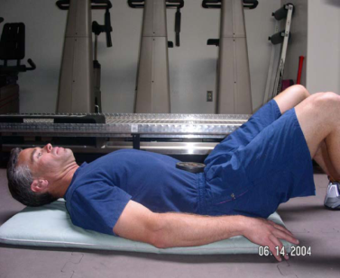
Lying Draw In (knees up)

Lie supine with knees up
Raise head (to relax the Rectus Abdominis
Attempt to pull the belly button through the spine then pull diaphragm up
(like taking a deep breath)
Remember to breathe while doing each repetition
Pull the Abdomen further in with each repetition

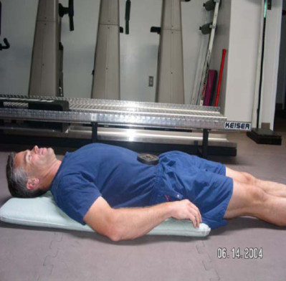
Lying Draw In (legs straight)

Lie supine
Raise head (to relax the rectus Abdominis
Attempt to pull the belly button through the spine, and then pull diaphragm up
Remember to breathe while doing each repetition
Pull the abdomen further in with each repetition

Sitting Draw In
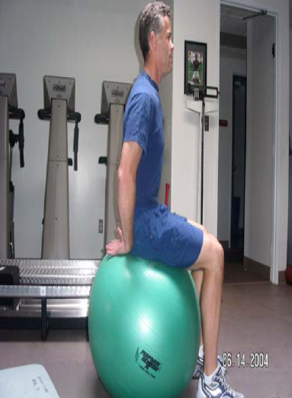
While sitting on Physic Ball attempt to pull the belly button through the spine then pull diaphragm up (like taking a deep breath) Remember to breathe while doing each repetition Pull the Abdomen further in with each repetition

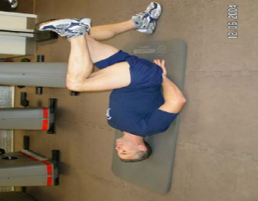
Alternating Leg Pulls Alternating Pulls--Knee UpsKnee Ups
Lie supine with knees up, place hands in the small of your back. Attempt to pull the belly button through the spine, then pull diaphragm up spine, up. Raise one leg until the knee is pointed to the ceiling or until you feel your lower back touch your fingers touch fingers. Lower the leg to the floor without arching your back, if your back begins to arch STOP and return your leg to the starting position. Repeat the exercise for the other side. Remember to breathe while doing each repetition. Pull the Abdomen further in with each repetition.

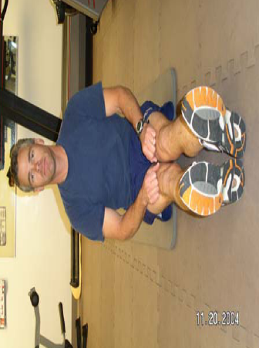
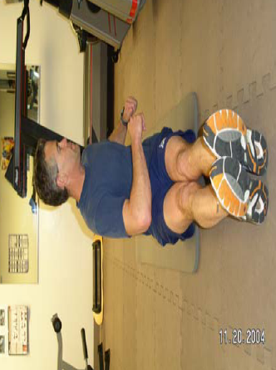
Sitting Trunk Twist Sitting Twist
Sit with feet straight in front of you, toes up, head forward and elbows at your sides at a 45 degree angle degree angle. Rotate torso to the side until you reach full range of motion DO NOT TWIST OR TORQUE TORSO PAST NORMAL RANGE OF MOTIONRANGE MOTION. Rotate torso back to center and repeat to opposite side repeat side. Remember to breathe while doing each repetition.

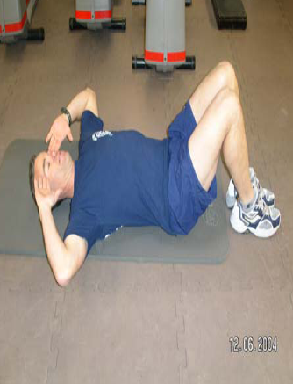
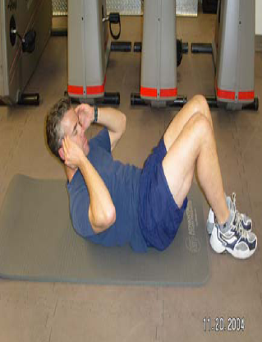

Draw In Crunch Draw Crunch
Lay supine with knees up. Gently place hands on ears (do not pull on back of head). Curl up from the head one vertebra at a time Slowly reverse the curl ending with neck and head. Remember to breathe while doing each repetition.

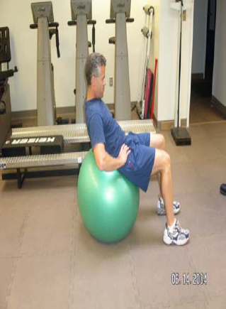
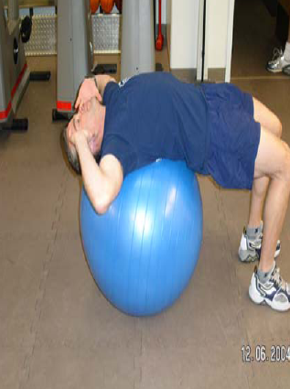
Ball Crunch Ball Crunch
Lay supine on ball with head resting on ball resting ball. Roll your hips and chest up from the head trying to move one vertebra at a time. Slowly reverse the curl ending with neck and head with head. Remember to breathe while doing each repetition doing repetition

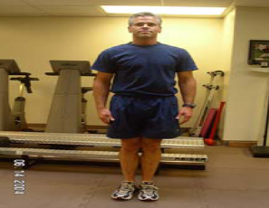
Side Bends

Stand up with head, chest, toes forward and hands at side
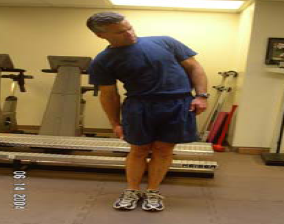
a neutral spine
Reach down leg while maintaining contact with legs DO NOT FORCE PAST NORMAL Maintaining RANGE OF MOTION, repeat on opposite side •

Glute Bridge (thrust and hold)

Lay supine on the floor, with your knees bent at 90 degrees and feet flat on the floor
Attempt to pull the bellybutton through the spine, and then pull diaphragm up
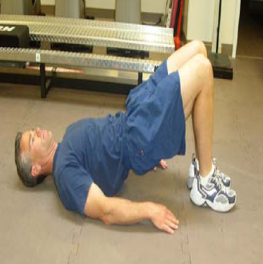
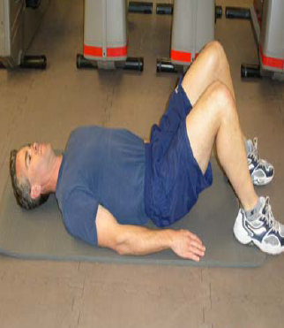
Bridge your hips towards the ceiling by firing your glutes and hold
Only shoulders and heels remain on the ground
Lower hips toward the floor without touching the floor and repeat
Remember to breathe while doing each repetition
Pull the Abdomen further in with each repetition

Superman Lower
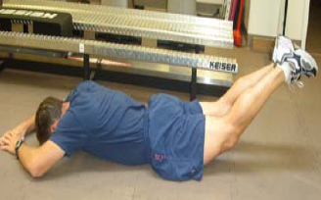
Attempt to pull the bellybutton through the spine, then pull diaphragm up Lay prone on the floor with arms in the overhead position the position. Raise the lower body in an isometric contraction while activating the glutes and hold. Maintain a neutral spine. Lower to the floor and repeat. Remember to breathe while doing each repetition.
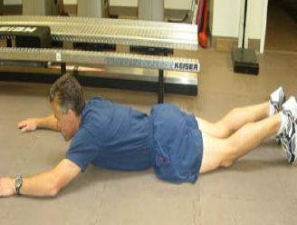

Superman Upper

Attempt to pull the bellybutton through the spine, and then pull diaphragm up
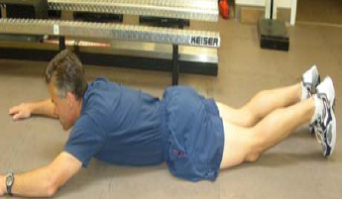
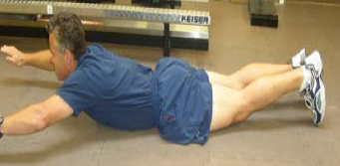
Lay prone on the floor with arms in the overhead position
Raise the upper body in an isometric contraction and hold
Maintain a neutral spine
Lower to the floor and repeat
Remember to breathe while doing each repetition

Elbow Bridge on Knees
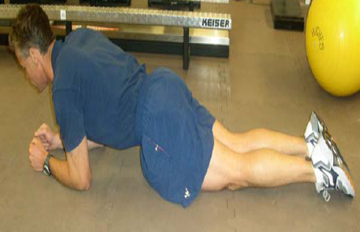
Lay face down in a prone push up position forearms resting on the floor. Elbows are under your shoulders bent at 90 degrees. Maintain a neutral spine. Remember to breathe while doing each stabilization

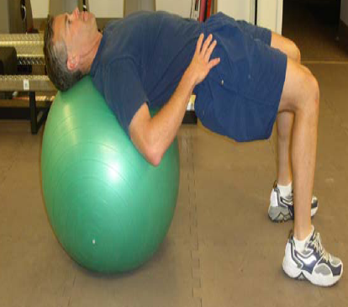
Back Bridge

Lay supine with the ball between your shoulder blades, hips fully extended and knees bent at 90 degrees.
Attempt to pull the bellybutton through the spine, and then pull diaphragm up. Attempt to keep a straight line between your knees and your shoulders. Remember to breathe while stabilizing. Pull the Abdomen further in with each repetition r t

