WelFit Participants,

This program is a collaborative approach between Management and Labor to develop, promote, enhance, and maintain the wellness and fitness of our most important asset, the firefighters who deliver service to the citizens of Fairfax County. Our goal was to develop a positive educational approach to wellness and fitness in the fire and rescue service.
Fairfax County Fire and Rescue Department developed an overall wellness fitness program to maintain uniform personnel physical and mental capabilities. The program is designed to be positive and requires mandatory participation by all uniform personnel. It allows for on-duty time participation utilizing facilities and equipment provided or arranged by the department. It encompasses rehabilitation and remedial support for those in need; contains training and education components with the goal to be reasonable and equitable to all participants.
The fire and rescue service requires that we face our destiny of keeping our firefighters fit today. The Fairfax County Fire and Rescue Department requires each and every member to fully participate in the program. With cooperation and participation, we will realize our goals of increasing firefighter wellness and reducing the number and impact of injuries that occur to our members.

Ralph Pisani Captain 1

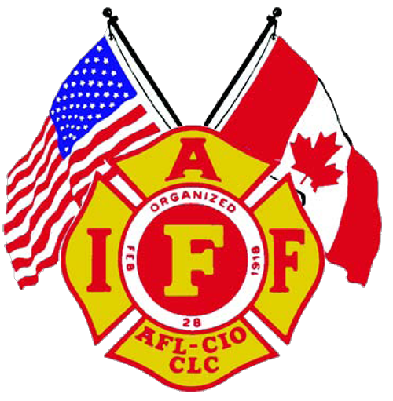


Chapter 1

Introduction

The Fairfax County Fire & Rescue Department (FCFRD) has been privileged and honored to share in the development of the Wellness & Fitness Initiative. The initiative established by the International Association of Firefighters and International Association of Fire Chiefs in collaboration with fire and rescue service management has set the standard for overall physical wellness and fitness for management and labor. FCFRD strives to meet or exceed the standards established.

Historically firefighting is one of the most dangerous professions. Over the past one hundred years, more than one hundred firefighters a year loose their lives in the line-of- duty. In addition, over one hundred thousand firefighters across the nation suffer injuries in one degree or another. While technology has provided a much higher level of respiratory and thermal protection for firefighters, it is still an arduous profession in which strength, agility, flexibility, and endurance are necessary to perform firefighting tasks safely and efficiently.

The FCFRD has supported this program by establishing the positions for the Wellness Fitness (WelFit) program. Oversight for the WelFit Program is provided by the Health Programs Manager, WelFit Program Manager, and Strength Conditioning & Exercise Specialist. It is the responsibility of the WelFit Program Manager to oversee the overall fitness needs of the department members. Among the responsibilities of the WelFit Program Manager is the oversight of the Peer Fitness Trainer Program, the Candidate Physical Ability Test, the Work Performance Evaluation, and satellite fitness facilities and equipment needs.

FCFRD believes that the best way to provide the highest level of service to the community it serves is to ensure that the best resources are available to deliver the service. This includes both the mechanical and human resources. In keeping with that philosophy, the FCFRD adopted and implemented the International Association of Fire Chiefs' (IAFC) and the International Association of Firefighters' (IAFF) Joint Labor-Management Wellness and Fitness Initiative (WFI) in 2000 to protect its firefighters. This comprehensive program incorporates the five following components:

- Comprehensive Occupational Medical Examinations
- Fitness Evaluations
- Behavioral Health Services
- Rehabilitation Services
- Immunization & Disease Screening
- Data Collection and Reporting

FCFRD firefighters are required to complete comprehensive medical and fitness exams annually. The exams are performed in a confidential setting in which the member has the opportunity to have a consultation with a physician. The evaluations include a full blood panel assessment, hearing and vision exams, chest x-rays, and a fitness exam. These types of exams have shown to be very helpful to the individual and the organization. By detecting potential medical or physical aliments ahead of time, they increase the quality of life for the individual and reduce the potential costs associated with firefighter-specific injuries.

This is a tremendous benefit to the members of the FCFRD and the communities they serve. A healthy and fit firefighter can perform more efficiently and more safely thus increasing effectiveness and longevity. One does not need to go far to see the increasing cost of workers compensations claims and the associate detriments to the organizations. This program proactively addresses many of the concerns for firefighter safety and community protection.
For more information on the IAFF/IAFC Joint Labor Management Wellness and Fitness Initiative, please visit their website.

WelFit Mission Statement

Provide the resources necessary to ensure the highest level of wellness fitness readiness for fire and rescue personnel. The Fairfax County Fire and Rescue Department recognizes this as an essential component to meet the departments’ mission statement.

Health and Safety Core Value

Health & Safety: We believe our health and safety are essential to fulfilling the Fire & Rescue Department’s mission. We are committed to providing the best health and safety programs for our member’s well-being and operational readiness.

Why do uniformed personnel need wellness?

Research has repeatedly shown the need for high levels of fitness to perform safely in the fire and rescue service. The fire and rescue provider is subjected to long hours, shift work, sporadic high intensity work, strong emotional involvement, and exposure to human suffering and loss. This places fire and rescue providers among the most stressful occupations in the world.

Physical fitness is known to reduce the risk of injury and is an integral part of fire and rescue training. In order to encourage group participation in our physical fitness program all uniform personnel are required to participate in daily fitness activities which include: weight training for strength, aerobic training for endurance, and core training for stability. Shift Leaders are to ensure all members participate in daily physical fitness as is stated in S.O.P. 02.03.09. Shift leaders and company officers play an important roll when it comes to fitness participation always encourage the shift members to engage in physical fitness activates on and off duty, lead by example. The department supports this by allowing employees, while on duty, to utilize the facilities and equipment provided or arranged by the department.

The Fairfax County Fire & Rescue Department has developed an overall wellness fitness system which includes the Wellness Fitness Center. At the Wellness Fitness Center we provide training and education in order to support the fitness program established by the department. In addition, the center provides for rehabilitation and remedial support for those in need.

Chapter 2

Wellness Fitness Program Manager
Job Description

Distinguishing Characteristics of the Class:

Captain positions in the Emergency Services Division function as full shift supervisors, with all related administrative, managerial, and operational responsibilities. Captain positions in the remaining divisions serve as section leaders over specialized positions or functions, such as fire investigation, fire protection, haz-mat, training, communications, and the wellness fitness program manager.

The Wellness Fitness Program Manager develops and oversees the WelFit Program.
The duties and responsibilities for this position include, but are not limited to:

- Managing the department’s Fitness Training Program and ensuring the number one priority is to assist field personnel with physical fitness training. This is done through the use of the Peer Fitness Trainers, and the Strength & Conditioning Exercise Specialist.

- Management of the Peer Fitness Trainer Program to include the development and implementation of a written plan for training requirements, certifications, program activity budget analysis.

- Coordinating a joint work effort for return-to-work policies between the Public Safety Occupational Health Center (PSOHC) the PSOHC Physical therapist, and the Strength & Conditioning Exercise Specialist.

- Developing and implementing educational wellness programs for department personnel.

- Maintaining the efforts and development with the department’s position on the IAFF/IAFC Joint Labor Wellness Imitative Task Force as primary contact for wellness and fitness issues.

- Coordinating the biannual Work Performance Evaluation, fitness-for-duty and return-to-work exams.

- Coordinating, along with the Training Division, the recruit fitness orientation and assigning Peer Fitness Trainers as oversight for the recruit fitness training program.

- Ensuring all fire and rescue department personnel have the ability to contact Peer Fitness Trainers, and the Strength Conditioning & Exercise Specialist.

- Managing the administration of the applicant Candidate Physical Ability Test (CPAT), and orientation program.

- Managing the department’s inventory of fitness equipment to include purchasing, maintaining, and researching new exercise equipment.

- Submitting justified proposals for fitness equipment purchase and physical training educational opportunities through grant funding and other sources.

