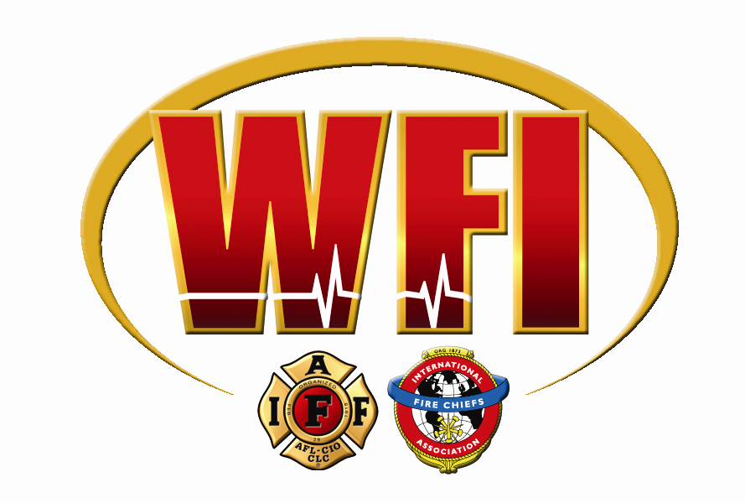

WELLNESS/fitness program

SAMPLE MEMORANDUM OF UNDERSTANDING /CONTRACT

The _______ Fire Department and _______ Firefighters, IAFF Local _____ recognize the value of a healthy, well and fit workforce. The parties will develop and implement a Wellness and Fitness Program consistent with the recommendations of the IAFF/IAFC Joint Labor Management Wellness Fitness Initiative (WFI). The ____________ Fire Department will implement a wellness/fitness program for each fire fighter to obtain a level of wellness/fitness consistent with the duties he or she may be called to perform. The wellness/fitness program shall be a positive program and not punitive in design; allow for age and position in the department; allow for on-duty time participation utilizing facilities provided or arranged by the City; provide for rehabilitation and remedial support for those in need; and be reasonable and equitable to all participants.

To achieve such a program a Labor-Management Wellness/Fitness Committee shall be formed within ninety days of the signing of this contract. The committee will consist of three representatives of the _______ Fire Department, three representatives of _______ Firefighters, IAFF Local _____, the fire department designated physician (non-voting) and an outside medical, physiological and wellness consultant(s) (non-voting) mutually chosen by both parties.

The Labor/Management Wellness/Fitness Committee shall be responsible for four primary areas:

Implementation of the WFI Program: Reviewing this Initiative and fully adapting the components to the _______ Fire Department.

Statistics and Health: Developing statistics on experience with lost time and costs due to disease and injury so as to demonstrate how the implementation of the WFI program will avoid or reduce disease and injury; and be cost effective.

Wellness/Fitness Program: Developing program objectives; developing the program and related activities (e.g. peer fitness trainers (including certification), workshops, smoking cessation and weight control programs); preparing budget.

Executive and Marketing Functions: Identifying specific objections to the program, developing answers or procedures to overcome the objections, enlisting the help of critical support groups and individuals; investigating legal implications of the wellness/fitness program; establishing policies and directives.

